 | NEWSLETTER  #3
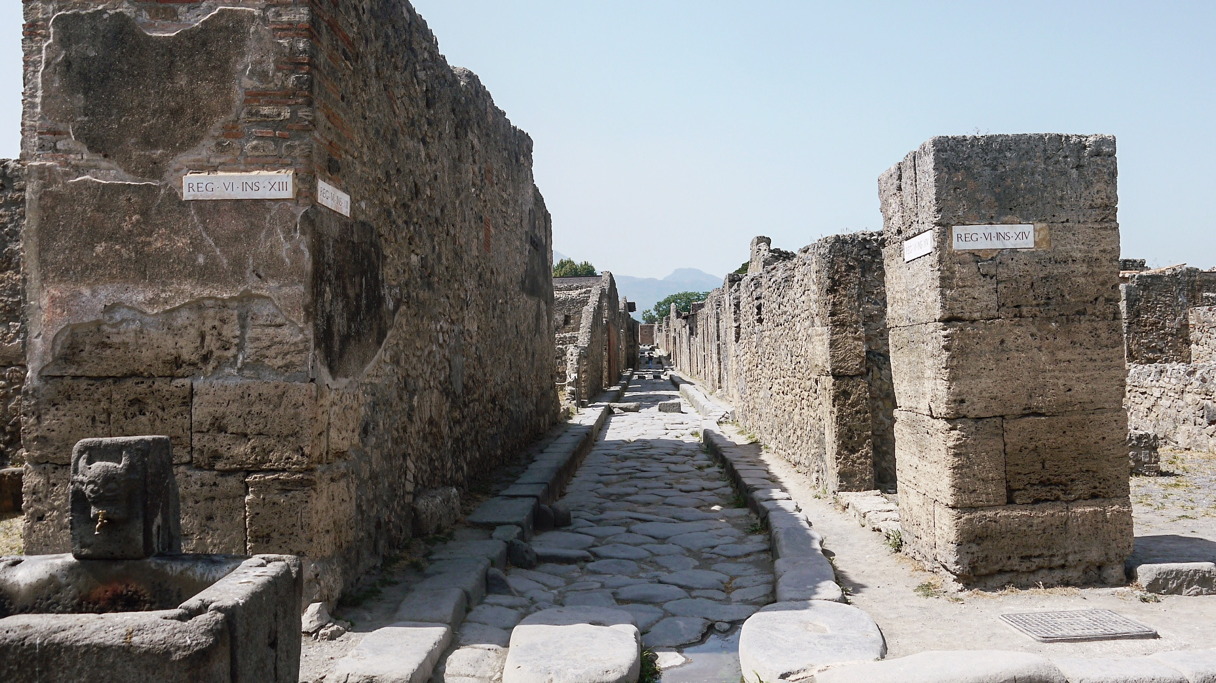

Cardiff Storm 3 – Independent Living and Direct Payments

Once again we had a really successful turn out for our most recent Cardiff Storm event covering the South East at the end of June. We’d like to say a massive thank you to all those who attended the event and to our wonderful speakers. Despite it being the hottest day of the year and Cardiff being at its busiest with all the Robbie Williams fans milling around, everyone still made the effort and made their way to our event.
The event was held at Little Man Coffee Company in the city centre where we discussed ‘Employment Opportunities and Direct Payments’.

The wonderful John Sanders was the first on our line up. He spoke with the group about job applications, the interview process and when to “disclose” your sight loss/ disability. This session sparked a great discussion amongst the group, people shared their positive and negative experiences around all types of interviews. Hannah, who’s 22, spoke about the difficulties of “disclosing” your sight loss during a group interview setting and how challenging it was. It was clear how complex the decision is of when, how and where you could and should “disclose” and what information is appropriate when applying for jobs in different sectors.

We then moved on to a presentation from the DWP (Department of Work and Pensions) who spoke about the Access to Work Scheme; what it is, the process and what you may be entitled to. They also talked through a project that the DWP are running up until November 2017 called Work Choice. It’s a scheme that’s run through the job centres to support disabled adults into work. Another informative discussion came out of this session that helped everyone gain a much better understanding of what is available to them, especially through the job centre.

Up next was Owen Williams, Director of WCB who gave a short introduction to Direct Payments and held a discussion about what people knew and listened to anyone’s stories and experiences.
After reflecting on the last few hours we decide that John Sanders would run another session around identity in the workplace and owning your eye condition in the next Cardiff Storm event. We’re looking at titling the next Southeast Storm Event as Inspiration and holding it in late Autumn.

If you’re interested in attending the next Southeast Storm event or want to know when the next one in your area will be please don’t hesitate to get in touch.

Bar work bamboozles me sometimes…

I live above a pub and so I spend many evenings sat with people who are usually far drunker than I. On top of this, my grandparents own the pub so as a result I often end up pouring the pints. Every once in a while my visual impairment becomes the topic of conversation and the comments and queries I receive from the customers are usually bizarre.

Before continuing I want to clarify something. I honestly believe that none of these people were meaning to offend me. These questions are often fuelled by Dutch courage and laced with a smidgen of ignorance and so I usually answer honestly, but I can't resist a little sarcasm ever once in a while.

Here are the most frequently asked questions I get whilst working behind a bar with a visual impairment:

- Do your eyes normally shake like that or are you allowed to drink on the job?

It's a problem many people with Nystagmus have faced before. My wobbly-eyes mean that sometimes people assume I'm drunk (even if a drop of gin hasn't passed my lips) but when I'm surrounded by alcohol their suspicions are strengthened. I've learnt over my time behind the bar that it's easier just to shrug off that question. People don't seem to believe me when I assure them I'm sober and trying to explain Nystagmus to someone who's 8 bottles of DoomBar under the table can be tricky.

- How do you know when the pint glass is full?

This question makes me roll my eyes because I hear it so often! However I try and hold back any sense of bitterness in my voice when I reply. My normal answer to this is usually accompanied with a smirk: ‘I stop pouring when it's overflowing’.

- So your Grandmother allows you behind the bar?

Of course she does! Why wouldn't she? - enough said on that one.

- Do you want the exact change? I imagine counting money must be hard for you.

I am aware that if someone says this then they are probably trying to be helpful but they have no idea how irritating it is! Of course I can handle money! How else do you think I pay for things? I know that contactless cards are pretty convenient for people with visual impairments but cash really isn't that hard to deal with. Coins are different shapes, sizes and textures and so I've learnt over time to recognize them by touch. I am perfectly capable of giving you your fifty pence change, don't worry about it.

I suppose in a way I'm lucky because many people who drink at the pub know my grandmother and by extension know that I'm Registered Blind but these four questions are still asked reasonably often. In a way, I've grown immune to them now but here's a word of advise for anyone who may have to deal with ignorant people's drunken, unexpected (and sometimes rather personal) questions.

You don't have to explain yourself to anyone: Particularly not a drunk stranger in a pub. Getting into a full-blown discussion about your visual impairment can be exhausting and unnecessary. Take everything with a pinch of salt and accept the fact that you can't educate pork. Also, they probably won't even remember it the next morning.

North Wales Storm 2

This July, Mared and I once again made the journey up to Llandudno to run a Storm event. After a long train journey we arrived in a sunny Llandudno and made our way to the Mostyn Gallery. It’s a beautiful venue with a great room, which was perfect for what we needed.

We were very pleased when Kate and Adam from Vision Support arrived and said they knew a few people who were coming. All in all we had a successful turnout with about 8 young people attending the event.

The session began by introducing the project and briefly going through the concession booklets for anyone who didn’t have the information yet, we spoke about the access to work information we’d gathered at our Cardiff event and then covered Direct Payments. We also showed the group our recent Rehabilitation and Independent Living video we created and asked for their feedback to find out what worked and what didn’t.

Altogether it was a great afternoon, everyone was really engaged with all the discussion and were really keen on having another event soon.

We’d like to thank everyone for a joining us and especially to Kate for all her hard work. We’re looking at doing a mini tour of North Wales in the new year, so if you’d like us to come to your area, please get in touch.

Footfalls through history

By Amy Gifford

During the summer I spent a week in the character-filled and rustically charming city of Naples, Italy, or, as I referred to it throughout the holiday, as a city comparable to a loveable rogue.

On one of the days, my brother Mike and I decided to visit the Roman city of Pompeii - a place that, as a history undergraduate, I should definitely visit whilst staying in Naples. Unsurprisingly I was not disappointed with the site at all, it was very much what I expected and more. In particular, the reconstructed theatre was absolutely beautiful, as it gave this aura of amazement. The sheer scale of it was truly astonishing. Despite being mesmerised by the sight in front of me, I was also terrified. My lack of depth perception alongside being registered blind, was quite tricky to deal with when the stone steps and seats were exactly the same colour. Even though this was a bit of a pain, I did not let it stop me from enjoying this historical site.

Exploring Pompeii was quite a challenge, but it was very much worth it, and for only €13, bargain!

As a history undergrad, Naples had a lot of interesting sites to offer and discover. After a long day’s exploration, tucking into a pizza with tomatoes from Vesuvius and a glass of white wine was simply bliss.

So, as someone with a visual impairment, I would say that it should not stop you from travelling the world and having fun. Do it. It’s worth it. Trust me!

Contact us

Email
megan@wcb-ccd.org.uk
mared@wcb-ccd.org.uk

Telephone
029 2047 3954

Facebook
facebook.com/StormWCB

Twitter
twitter.com/StormWCB

Website
www.stormwcb.org.uk

