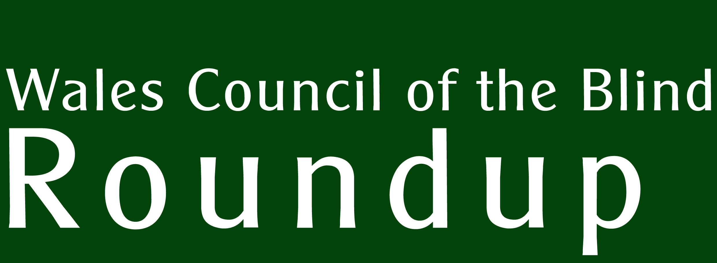 | Supported by  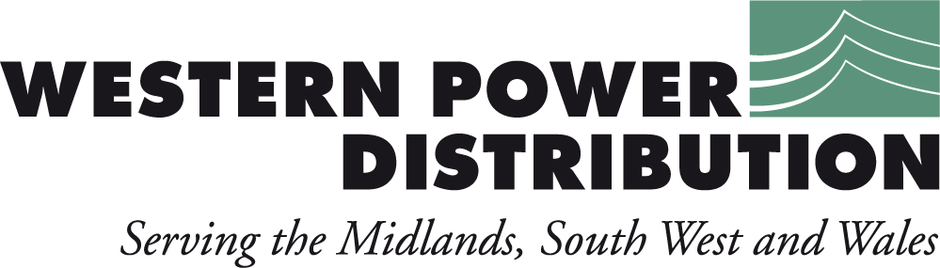  No. 35
The many shapes of Third Sector organisations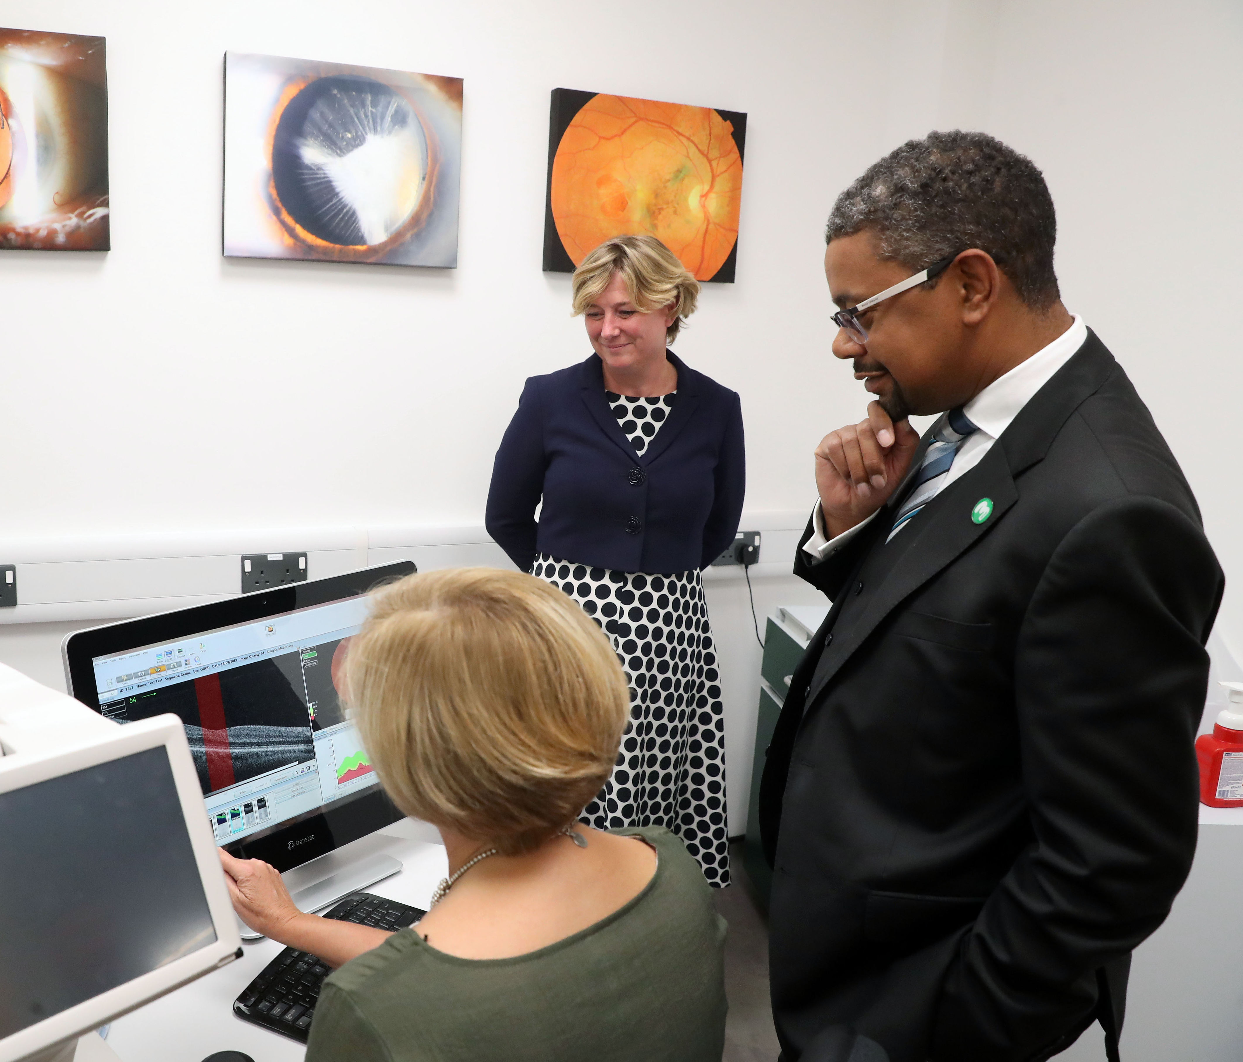
New Glaucoma clinic in Cardiff

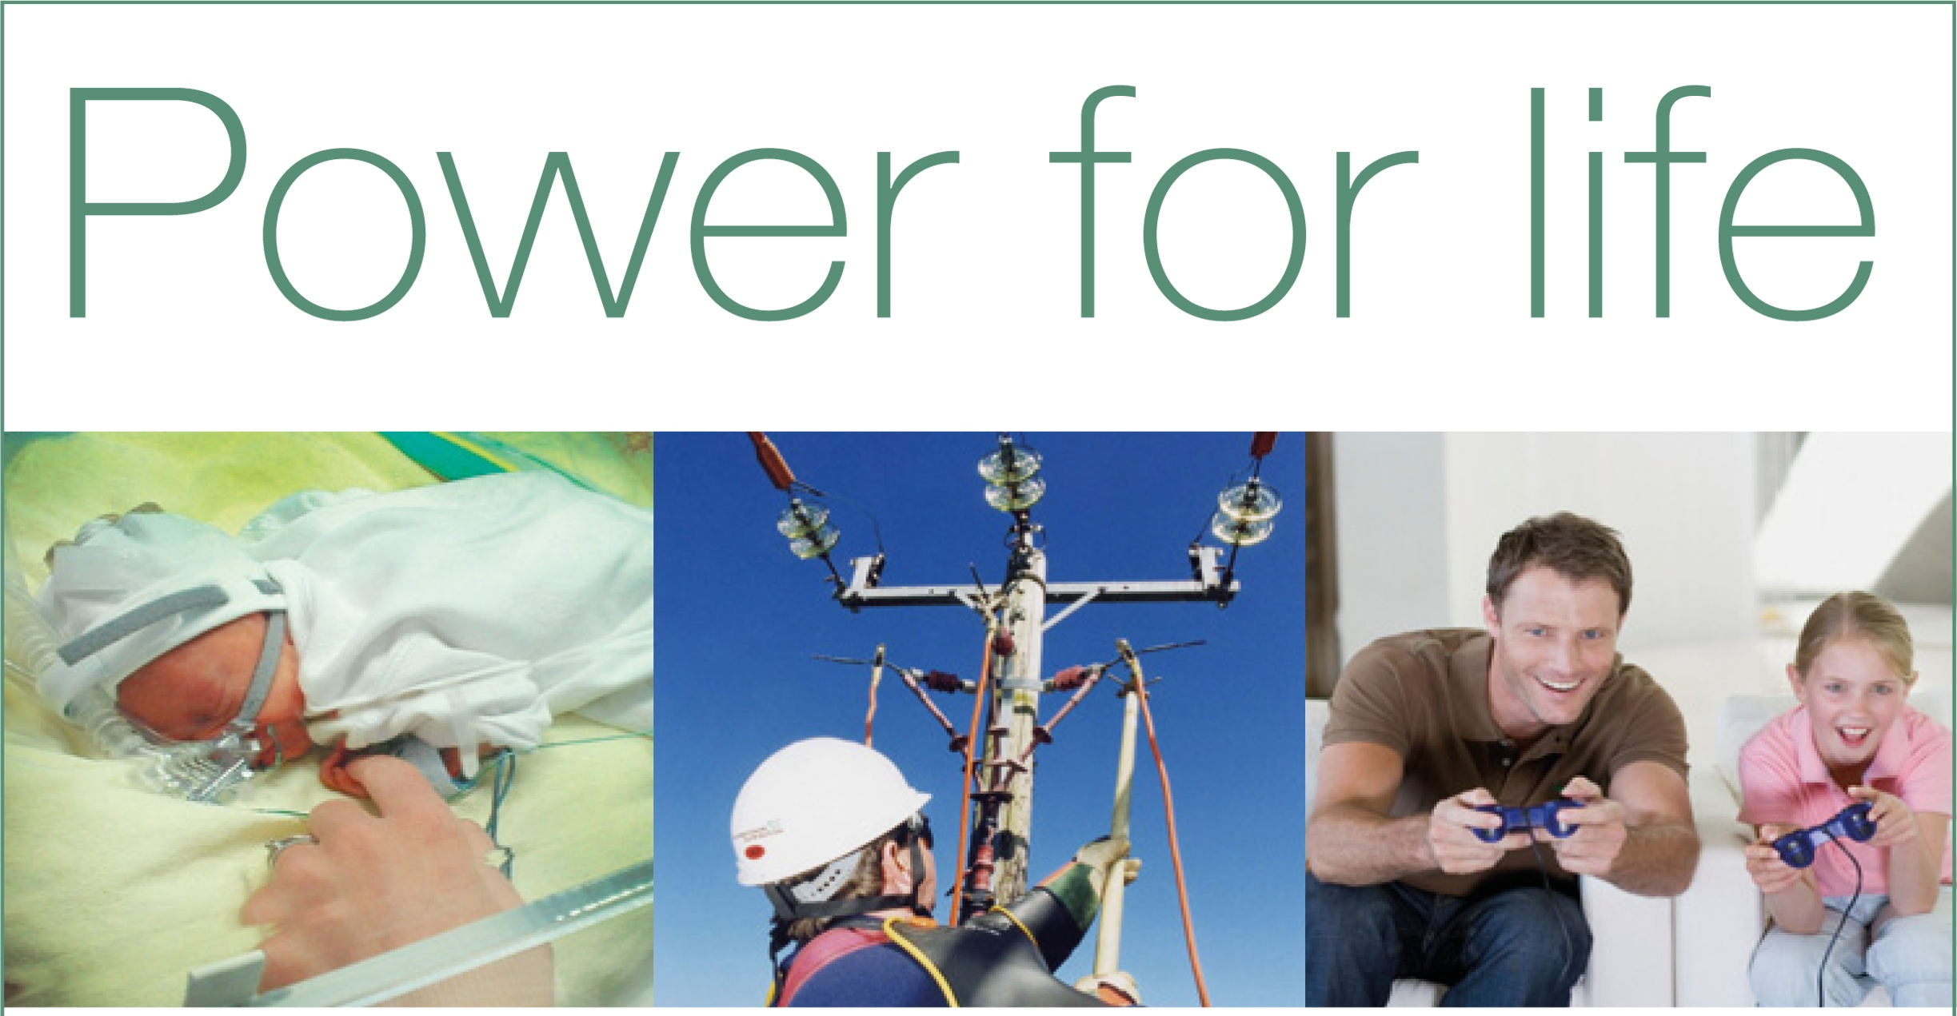
Delivering electricity to homes and businesses is about more than just cables and wires, poles and pylons. It’s about providing people with a service that they can depend upon to help them live their lives to the full.
At Western Power Distribution we are investing many millions of pounds long-term on our electricity network to ensure all our customers continue to receive the same world-class service.
We are proud to be leading the way in terms of customer service, network reliability, technical innovation and environmental care, but we are not complacent. This is why we will continue to set our own demanding performance targets and exceed those set by our industry regulator.
Our Target 60 initiative is a case in point, for when power interruptions occur its aim is to restore supplies within the first hour. This is a commitment our customers can depend upon.
To find out more about our plans for the future visit www.westernpower.co.uk or email info@westernpower.co.uk.
If you have a power cut – call 105 or 0800 6783 105

WCB Roundup is published quarterly by Wales Council of the Blind, 2nd Floor, Hallinans House, 22 Newport Road, Cardiff CF24 0DB. Tel: 029 20 473954.
Email: richard@wcb-ccd.org.uk.
Further copies, in audio CD or large print formats, are available. All editions are online at
http://www.wcb-ccd.org.uk/roundup.php
Advertise in WCB Roundup
WCB Roundup is sent to more than 2500 people, in a variety of formats. We are a not-for-profit organisation that hopes to recoup its costs. We seek advertisers for our newsletter so that we can continue to produce this valued journal. Advertisers will reach a readership of individuals with sight loss, optometrists, ophthalmologists, rehabilitation officers, social workers, and organisations working for blind, partially sighted and disabled people.
Our rates are (per edition):
Full A4 page: £150 (black and white) £250 (colour)
1/2 A4 page: £100 (black and white)
Enclosures: single sheet A4, supplied in a ready-to-go format: £200. Ask for quantity required.
Larger enclosures (such as booklets): please ask for quote.
To advertise in many editions, please contact us for discounts. Contact Ann via ann@wcb-ccd.org.uk or telephone 02920 473954.
The next edition of Roundup will focus on the range of Third Sector Support. Please let me know of any useful sources of information on this by emailing richard@wcb-ccd.org.uk

Editorial

This edition of Roundup looks at the Third Sector, its makeup, and the types of services it offers. We also share information about a WCB Project to map and evaluate services throughout Wales. It shall be a survey of what is being provided by third sector organisations and of what people would like to see provided. Many organisations carry out this type of survey with its members as part of their own self-evaluations, but this project aims to give an overview of the varied provision throughout Wales. Furthermore, it may be helpful to get a picture of what exactly is being offered and attempt a kind of categorization so that a mapping exercise has a unified language to work with.

Included with this edition is Perspectif Supplement showing the records WCB currently holds on third sector services related to sight loss. We welcome amendments and additions to these. Please email richard@wcb-ccd.org.uk with updates.

Also, Storm WCB newsletter contains two interesting pieces from Dan and Al about their experiences.

Annual Wales Eyecare Conference 2019

Many familiar faces spoke at this year’s conference and with the welcome return of the hugely popular Gwyn Williams, who’s brand of humour brings a little life to the proceedings, the day flowed effortless through its programme.

The keynote speech came again this year from Vaughan Gethin AM. Vaughan is the Minister for Health and Social Services and has personal experience of a sight condition, glaucoma, so comes from a position of empathy. His speech is given below.

There is always some scope for an injection of humour in the serious subject of eye health and sight loss. UCAN Productions brought this as part of the Storm WCB project in two short theatrical sketches. The first, ‘There is Nothing More We Can Do’ examined the different outcomes between a person newly diagnosed who is sent on their way without support and another who is referred to support such as rehabilitation. The radically different outcomes were highlighted in a performance of cartoonish humour that really got the message home. Their second piece, “What the Social Model Means to Me’, gave a clear explanation of the difference between the medical and social models of disability, illustrated by a comedic boxing match with inflatable gloves! The UCAN team is always welcome and popular at the conference: they give a fresh, service-user’s perspective against a backdrop of more service-led presentations.

More patient voices came from Niamh Williams, Zulfikar Ali, Shameem Hussein and Bablin Molik. Niamh gave her perspective on her transition from school through college to adulthood. She spoke positively of her support from SenCOM but highlighted the problem of it ending after leaving school and the lower level of support provided in further education by the college. Zulfikar, Shameem and Bablin spoke about the experiences of BAME people with sight loss accessing health and social services.

Ian Moran, Chair of the Welsh Rehabilitation Officers Forum, spoke on the importance of the Certificate of Visual Impairment as a means of getting ongoing support from rehabilitation while Rebecca Bartlett talked about research to ascertain the closeness of agreement between opthalmologists and optometrists in identifying patient eligibility for certification. Rebecca reported a close match in the trial and is hopeful that the finding will go some way in supporting the potential role of LVSW optometrists in the process of certification of vision impairment

Speech: Vaughan Gethin AM, Minister for Health & Social Services

Working in collaboration, we have achieved a huge amount since the launch of the Eye Care Delivery Plan in 2013:

- the establishment of an all Wales multi-disciplinary steering board to monitor and implement the delivery plan;
- the establishment of multi-disciplinary eye care collaborative groups in each health board to consider, develop and implement the delivery plan’s recommendations;
- the roll-out of national screening of children’s vision at age 4-5 across all health boards;
- Secured £1m through the Health Technologies and Telehealth Fund to improve IT connectivity in primary care to improve patient care and release capacity in hospitals;
- Secured £500k new funding for health boards to develop new service models to deliver wet-AMD in primary care;
- Secured £600k to enable optometrists to manage patients in primary care, via the Wales Eye Care Service;
- Secured £225k for optometrists to upskill and undertake higher qualifications in medical retina, glaucoma and independent prescribing to be able to manage increasingly complex patients in primary care.

Rapidly advancing technology will have a great influence on improving eye care services; however, a key way to reduce sight loss is to encourage patients to be more involved in their own eye care. The Welsh Government Ophthalmic Communications Group will help to drive forward communications and get key messages out to the public. These messages will signpost citizens to the services available, equipping them with the right knowledge and information to make the right choice about their health needs.
Every aspect of health care, technology and advances in clinical techniques will continue to provide both opportunities and challenges to the delivery of our services. The transformation and revolution from within has begun with our eye care services, but we must not rest as much work is needed to provide a service fit for purpose.

To progress this, the Welsh Government established a service reform group to scope, develop and deliver a national Wales Eye Care Service with two key threads; a sight test and eye health check. The Chief Optometric Advisor is leading on the scoping exercise. Implementation of the Delivery Plan recommendations has been the springboard to this development. Looking forward, the aim is to develop a system that is fit for purpose for the 21st century.

With an increasingly ageing population, growing demands on the NHS and eye care services in Wales and huge advances in technology, there are key questions to be answered:

- What will the future of eye care services look like?
- How will new technology influence eye care and service delivery for citizens across Wales?

Our focus to date has been about providing seamless eye care services across primary and secondary care, maintaining quality care and reducing service variation and inequalities.

Last year, I talked about the new eye care outcome measures introduced in Wales, a first in the UK, treating patients with the greatest need first and prioritising appointments for sight threatening eye disease. We knew implementation of the new measures would be challenging, but it was absolutely the right thing to do.

Since last year’s eye care conference, health boards began shadow reporting against the new outcome measures. The result showed us exactly how we needed to transform our services to cope with the demand.

As a result of this, I made funding available to support organisations and to help NHS Wales transform eye care services. In total £3.3m was awarded to health boards. The funding was aimed specifically at supporting eye care services and the shift in care closer to home and to tackle the growing capacity issue in the acute sector.

The plans supported include:
- Expanding or establishing services in the community, to ensure patients are seen in the most appropriate setting and by the most appropriate person;
- Introducing and further development of virtual clinics;
- Expanding the skill mix of staff, to include nurse injectors and optometrists, to safely share care between community and hospital eye care professionals.

I am pleased the current picture shows a marked improvement since health boards started shadow reporting and represents this investment made in the service and the clinical engagement.

It has long been recognised that an integral part to the transformation of eye care services in Wales is the effective sharing of information across all professionals involved in delivery of the service.

In March 2019 I announced £7.087m funding for the introduction of a new digital system for eye care across primary and secondary care.

- Referral from optometry practices to hospital eye services will connect the whole system and provide the ability for safe, timely referrals between optometrists in the community and hospital eye services, reducing the need for some patients to be seen in hospital.
- The introduction of an Electronic Patients Record will enable the expansion of ‘shared care’ thus further avoiding unnecessary delay, administrative duplication of information and improved outcomes for citizens in Wales.

Procurement of the new digital system, which is being managed by Cardiff and Vale University Health Board on behalf of NHS Wales, is in the final stages. I expect to make an announcement in the coming months on this exciting development.

It is vital for us to meet our targets and reduce the incidence of sight loss in Wales. Despite the investment made in services and the continued hard work of all involved in providing our eye care services, much work is still needed. “A Healthier Wales” called for “a revolution from within” to drive the changes we need to see in our health and social care system. We must drive the changes needed so that we are able to meet the needs of current and future generations in Wales.

Our vision is for everyone in Wales to have longer healthier and happier lives and to be able to remain active and independent, in their own homes, for as long as possible. People will only go to a general hospital when that is absolutely essential. Hospital services will be designed to reduce the time a patient spends in hospital, and to speed up their recovery. The shift in resources to the community will mean that when hospital-based care is needed, it can be accessed more quickly.

This approach is key to transforming our eye care services and building a sustainable service for the future. Our eye care workforce is the future of the service, working to the principles of prudent healthcare and delivering clinical leadership to ensure all clinicians are working at the top of their licence.

To recognise and support this approach, further investment has been made in additional qualifications for optometrists, orthoptists and ophthalmic nurses in Wales. In our hospital eye clinics, up-skilling our professions so that they are only seeing the complex cases, with the support of the whole eye care team is essential.

Additional funding has also been made available through Health Education and Improvement Wales to strengthen our primary eye care teams. This investment has built upon the previous investment made by the Welsh Government in glaucoma, medical retina and significantly in Independent Prescribing for optometrists.

The future of sustainable services in eye care requires all clinicians to work together in a seamless manner: managing patients that only they can manage and linking together using the digital solutions that are being made available. This whole system change, when achieved in collaboration, will revolutionise services.

I cannot emphasise enough how important it is for all stakeholders involved in the delivery of our eye care services to look to the future and embrace the changes required for us to achieve the transformation outlined in ‘A Healthier Wales’.

Health Minister opens Glaucoma Centre.

After his appearance at the Eyecare Conference, Vaughan Gething officially opened the Glaucoma Ophthalmic Diagnostic Teaching and Treatment Centre (ODTTC) at the School of Optometry and Vision Sciences.

The clinic, which has been established in partnership with Cardiff and Vale University Health Board, will offer a more streamlined and improved experience for glaucoma patients in Cardiff. The partnership will also provide the opportunity for students at the School to be actively involved in real-life glaucoma management.

University Hospital Wales will use the Clinical and Educational Research Facility (CERF) at the School every Wednesday to assess and review glaucoma patients. Optometrists and Consultants at the clinic have the unique ability to use electronic patient records, which enables the clinic to share patient records, including images virtually between the community and hospital clinic.

Professor Marcela Votruba, Head of the School of Optometry and Vision Sciences said: “We are delighted to have the opportunity to host the Ophthalmic Diagnostic and Treatment Centre at our School. The clinic provides us with the exciting opportunity to contribute to eye care delivery in Wales, whilst receiving an increase in meaningful real patient encounters for both our students and academic researchers. This is vital to our wider vision of improving optometric education and will contribute to our aim to carry out impactful research in sight and vision loss.”

The ODTTC has already been seeing patients and the School looks forward to working more closely with the community and the Cardiff and Vale Health Board.

Further information can be found on our website - https://www.cardiff.ac.uk/optometry-vision-sciences

The many shapes of Third Sector organisations.

What do we mean by ‘Third Sector’?

A map of the density of charities by local authority shows, perhaps surprisingly, that the highest number of charities per 1000 population occurs (in Wales) in Powys with 918 charities (6.9 per 1000 people). The lowest percentage (2 or less per 1,000 population) occurs in Swansea, Bridgend, RCT, Merthyr, Caerphilly, Blaenau Gwent and Newport (Source 1). The implication here is that more densely populated areas suffer from a per capita shortfall of support, but further research would be necessary to determine that.

So, what do we mean when we talk of the Third Sector? The Northern Bridge Public Policy Engagement toolkit includes within its definition of the Third Sector:

- Charities;
- Voluntary and community organisations;
- Social enterprises and cooperatives;
- Think tanks and private research institutes (this does not include universities and colleges).

Some organisations, such as housing associations, have been spun off from government and are considered quasi-third sector groups, even though they deliver public services.

What does the third sector do?

Typically most third sector organisations devote themselves either to a particular issue that needs solving (for example, climate change or unaffordable housing); or to a particular group in society (for example, dementia sufferers, or women facing cultural barriers to education) who requires support and representation. They may provide services related to these issues (for example, running a women’s shelter, or providing legal advice). Some organisations (particularly think tanks and research institutes) may work on a whole range of issues, but apply a particular philosophical and political filter. Their focus may be local, national, or global.

Third sector groups try to achieve their aims through a wide range of activities. Some, such as fundraising, providing services, or providing other forms of direct support and advice to the groups they help, are about immediate action. However, third sector organisations usually also want to back up direct assistance with long-term or systemic change, involving changes to relevant local, national, or international policies. They seek to bring these policy changes about in lots of different ways, all of which offer potential opportunities for academic collaboration or input.

Carrying out or commissioning research

Many third sector organisations either employ their own researchers, or commission independent or academic researchers, to carry out investigations into subjects that affect the groups and issues they deal with. In addition, they will also aim to be widely-read in the existing and emerging academic research in relevant fields. Research helps third sector organisations identify emerging issues they should focus on, and provides evidence to back up their policy proposals and campaigning. This is an obvious way your research can make a real difference.

Public campaigns

Third sector organisations also aim to raise public awareness and shape public perceptions about particular issues. They do this through public campaigns that may use a range of traditional and social media to get their message across. These campaigns may be aimed at the general public, or they may be targeted at certain groups or sectors, and this will affect media strategies and types of platform chosen. Third sector organisations want these campaigns to be as credible and authoritative as possible, so this is another area where academic research or an academic viewpoint can be of real value.

Lobbying or advocacy

Third sector organisations seek to bring about policy change by lobbying politicians, and by influencing government officials and civil servants responsible for the policy areas which impact on the groups or issues they represent. Depending on the organisation’s area of interest, they may lobby local MPs or the responsible minister, submit evidence to relevant select committees, or brief local or national government bodies. This is another point where your research can be valuable: third sector organisations need evidence to support their recommended actions, and they may wish to collaborate with academics on a joint submission or briefing. [Source 2.]

Aims and mission statements.

We can illustrate the different core activities of third sector organisations through some example mission statements.
Snap Cymru’s mission statement reads: “SNAP Cymru will empower families (children and young people, their parents and guardians) to have their voices heard within the area of Additional Learning Needs and Disability and support them to influence policy and practice in the planning and delivery of services at local, regional and national levels”

This is an example of an organisation focused on effecting change through the voices of its beneficiaries. They may offer additional direct services to support their beneficiaries and to raise awareness but their main purpose is focused on empowering people to exercise their rights.

Cancer Research UK describes itself as “dedicated to saving lives through research. Our mission is to prevent, control and cure cancer through our ground-breaking research and in the last 40 years our work has helped double survival rates.” Clearly, the organisation is focused on directly combating a specific medical problem, and does this by raising charitable donations to fund research.

The Wales Council for Voluntary Action describes its purpose as “the national membership organisation for the third sector in Wales. WCVA promotes volunteering, governance, sustainability and engagement by providing training, information and support to charities, voluntary and community groups & social enterprises.” This type of charity, sometime called an umbrella organisation because it embraces a network of other organisations, does not necessarily provide direct services to the general public. Instead, it offers support and guidance to charities to help them make the most of their skills and assets and to provide information on governance.

So, how can we group the services offered by third sector organisations in the sight loss sector?

Visionary, the umbrella organisation for sight loss across the UK, has identified the following themes to encapsulate the types of service that can be offered by organisations for people with sight loss:

- Lifelong advice, support and information on education, training, employment, accessible information, welfare and benefits, access to leisure activities;
- Social inclusion and peer support – somewhere to go and someone to talk to, meeting and talking to other people with sight loss;
- Digital inclusion – teaching and encouraging IT skills for independence and communication;
- Prevention, early detection and effective treatment and the links between health and the third sector;
- Early intervention and post-diagnosis support including practical and emotional support;
- Habilitation, rehabilitation and independent living skills are sometimes outsourced to Third Sector to support children and adults with reablement and independent living;
- Campaigning – such as holding local authorities to account.

Given these broad headings, it might be possible to create a list of service types at a more specific level.

Notes:
1. Guardian Datablog: https://www.theguardian.com/news/datablog/2011/feb/14/big-society-charities-third-sector-map

2. Northern Bridge toolkit: http://toolkit.northernbridge.ac.uk/engagingwithpolicymakers/engagingwiththethirdsector/whatisthethirdsectorandwhatdoesitdo/

The WCB Project: Stâd y Wlâd – State of the Nation

WCB has been funded by the Thomas Pockington Trust to run a project to produce a State of the Nation report on third sector services for blind and partially sighted people. This is to provide the sector with a stronger basis, through evidence of need, to seek sustainable funding for new and improved services.

There exists a network of organisations and smaller groups throughout Wales that deliver services ranging in type and quality potentially to an estimated 111,000 people in Wales living with sight loss.

We will work with our members to map services comprehensively and identify any gaps. We shall also look at the quality standards and evaluation methods, if any, that are being used by organisations. We will ask members which services they provide from a list of service descriptors suggested by Visionary. The research will also map support and services that would benefit people with sight loss, provided by organisations unrelated to sight loss.

There are opportunities for collaboration within the Third Sector and with other sectors. Indeed, many funding streams require you to explore these opportunities. Therefore, we will assess the appetite and potential for collaboration within the sight loss sector. Additionally, we shall look at collaboration across the sensory loss and disability sectors. This is line with a trend amongst commissioners of services towards broader sensory loss and pan-disability contracting. These conversations will involve local, regional, Wales-wide and UK-wide organisations.

The North and South of Wales are well served by North Wales Society for the Blind, Vision Support, Sight Cymru and Cardiff Institute for the Blind. These regional societies are distinguished by having paid staff and a large volunteer base, already delivering a range of services in their respective areas. There are a larger number of smaller volunteer-led local societies and groups that currently do not have the reach or capacity to deliver comparable services in their areas. Therefore there is a postcode lottery of services for people with sight loss in Wales. This project could explore the potential for a local society to work more closely with a more resourced regional society or, perhaps, identify where alliances could be formed regionally.

The final report will be used as a tool to provide evidence for funding bids for members to build their service provision. This report will be presented to the sector, Welsh Government, the seven Regional Partnership Boards and the 22 Local Authorities in Wales. We anticipate that this report, being service-user-centred, will go some way to influencing the choice and shape of new services and how the Third Sector is funded in Wales.

So, what will we be doing?

We will work with organisations to coordinate and complete a series of questionnaires to establish things like terminology, what organisations do and for whom, what their resources are and so on.

Alongside this we will ask their members what services they would like in their area. We shall be mindful that many organisations carry out their own user surveys, so we shall avoid duplicating these exercises wherever possible.
The aim is simply to get an overview of provision across Wales and to share our findings through a report.
What will it achieve?

The State of the Nation report will equip organisations to agree and develop new services.

Gaps in provision and areas for improved or new services will be identified. The project will recommend models of best practice and encourage collaboration where appropriate.

This research will also look at third sector services that professionals, such as the ROVI, would like to see developed so they can directly refer individuals. This goes hand-in-hand with identifying any quality standards or evaluation methods currently being used by third sector organisations.

People with sight loss will inform the report.

Service users must be listened to. There already exist service-user-led Steering Groups throughout Wales that would be called upon to report on current provision and to propose new services. WCB will gather opinion to give organisations a solid mandate to develop new services.

The report will influence the way the sight loss sector is funded in Wales.

The Social Services and Wellbeing (Wales) Act brought about a cultural shift where local authorities are to encourage citizens from the point of contact towards identifying solutions and seeking support from within their communities. This report will be used to influence funding through each of the seven Regional Partnership Boards.

The network of organisations will better understand current service provision throughout Wales.

The Wales Vision Forum recognises WCB’s role in mapping services. Perspectif and WCB’s information resources will be made use of to enable the sector to understand what is available in all parts of Wales. These resources will be updated following detailed mapping exercise.

Pathways between and through services will be identified.

We will work to identify pathways within existing provision such as Low Vision Service Wales, Social Care (through Rehabilitation Officers and Information, Advice and Advocacy teams), Health (through each of the Local Health Boards and the Certificate of Visual Impairment (Wales) Patient Leaflet) and other Third Sector partners (such as Stroke Association, Age Cymru). For instance, the information leaflet that accompanies the CVI does not seem to find its way to the patients in most instances. This project will map where it is happening.

So, WCB shall be seeking the support of our member organisations to build a picture of services in Wales. We shall also be seeking the views of service users to identify what is working well and what is needed.

If your organisation has services to include in the map or would like to find out more about this project, contact
Owen Williams on 029 20 473954 or
email owen@wcb-ccd.org.uk

Across the Sector

New CEO for Sight Cymru.

Dr Bablin Molik will start as Chief Executive Officer at Sight Cymru in November 2019. Her academic and research background in vision biology and glaucoma made her a well suited fit within sight loss sector. She has been working with Sight Cymru for 6 years and has led on numerous strands of work including developing and delivering sight loss prevention projects amongst primary schools and communities with high prevalence of sight loss, ethnic minority communities.

She has worked closely with Welsh Government and across the sight loss service sector through her work with MEGAFOCUS (Minority Ethnic Groups Association for Ophthalmic Care Uptake and Service) and sitting on EHEW (Eye Health Examination Wales), Communications and DESW (Diabetic Eye Screening Wales) advisory and governance group along with Public Health Accessible Communications board.

Sharon Becket, outgoing CEO said “Bablin is a huge force for good; she’s the most energetic person I know and has a passion for eye health, sight loss and inequality of outcomes.”

Bablin said “It is a huge honour to be leading a fantastic organisation and the team of Sight Cymru. I have big shoes to fill after taking over from Sharon Beckett. I am confident that with team support, passion and drive we will be taking Sight Cymru forward to ensure people are not losing their sight unnecessarily and that those with sight loss are accessing services they need in Wales.”

Sightlife celebrates its fifth birthday.

Sightlife, a group of people who have sight loss and are from lots of different ethnicities, has celebrated its fifth year this summer.

They meet in Cardiff and Newport, and have a wide variety of speakers and activities lined up. Often they go on outings – so for example have been to the Bay, to Penarth and various other places.

Recently they were asked to present at the Wales Eyecare Conference where they didn’t hold back in telling consultants that using jargon and unfamiliar language is difficult for anyone to understand, let alone those whose first language isn’t English. As many people from BAME communities have a higher likelihood of some eye conditions, understanding how to manage your sight condition is important. Very often they are not aware that they are entitled to loan magnifiers, lamps and sunshields free of charge, nor that in many instances their eye health should be checked regularly free of charge.

Another thing that binds the group together is a love of food and very often a member will bring in a tray of home-baked treats to share. Together they enjoy traditional festivals and food, celebrating and taking comfort in being able to share their culture with each other. Colourful saris and beautiful hand-woven materials abound – always guaranteed to cheer up the dullest of the British weather.

Group members celebrate each other’s birthdays and other special anniversaries and lovely friendships have been formed.

They’ve also developed lots of new skills – some of the group have helped Sight Cymru tell school children how to look after their sight, and others have helped with talks and training.

Sightlife are always keen to hear from new members so if you are from a minority ethnicity and have problems with your eyes please get in touch with Rhoda Williams 07929173014 or Zulfikar Ali 07847893587

Cruelty, cutbacks and consequences

Book review: “Crippled: Austerity and the demonization of disabled people” by Frances Ryan, published by Verso.

As a manager and charity trustee in the voluntary sector for the past decade, I’ve witnessed plenty of examples of life getting worse rather than better for disabled people. I’ve seen the impact of cutbacks in support for students with special needs. I’ve heard from families plunged into poverty by benefit cutbacks. And I’ve felt the anger and frustration of disabled adults kept out of a labour market covertly rigged against them.

Frances Ryan’s book provides both anecdotal and clear statistical evidence of the damage inflicted on disabled people across the UK by 10 years of unnecessary austerity. She also highlights the role much of the media plays in making welfare cutbacks possible with its relentless narrative suggesting many disabled people are “shirkers”, “undeserving” or “feckless”.

In six damning chapters Ryan shows how much worse life has become if you have a disability. Four million disabled adults were living below the breadline in 2018: that’s more than a third of all adults living in poverty in the UK. Another statistic from the many used to underpin her arguments shows that unemployed disabled people are 53% more likely to be docked benefits than claimants who are not disabled.

For all the Westminster Government’s rhetoric about taking back control, the opposite is often the case when it comes to independence for disabled people. Ryan finds widespread evidence that Government (supported by media) is reverting to the idea that disabled people are better segregated from the rest of society and don’t have the same rights to independence as the non-disabled. Recent funding caps on home support, for instance, mean that many disabled people have little choice but to move into a care home against their will.

The chapter on housing contains some of Ryan’s most harrowing evidence. Changes in benefit rules imprison some disabled people in inaccessible accommodation while forcing others out of specially adapted homes, ruining their lives and wasting past investment. She reminds us that the failure to implement equal access to housing, transport and social venues amounts to treating disabled people like “second class citizens.”

Another consequence of benefit cutbacks and the move to the widely criticised Universal Credit is disabled women being forced into prostitution. Ryan found evidence around the country of “a big increase in women selling sex after the introduction of benefit sanctions, not just to make ends meet but, in some cases, to provide the basics for their family.”

Ryan saves some of her harshest criticism of the Government’s callous attitude to disabled people for the chapter on children. Once again, it is disabled (even more than non-disabled) children who are suffering most from cuts such as freezing child benefit and the “two child limit” on child tax credits. For example, the roll-out of Universal Credit will cut child disability payments by a further £175 million. And this cut comes at a time when the number of disabled children is increasing and budgets should be rising instead of falling.

The book’s conclusion opens with a comment from a report by the United Nations rapporteur on extreme poverty Philip Alston: “British compassion for those who are suffering has been replaced by a punitive, mean-spirited, and often callow approach.” London-based Government ministers called the report “a completely inaccurate picture of our approach to tackling poverty.” So, where that leaves Ryan’s closing plea for all of us to find our compassion and social solidarity is anyone’s guess.

John Sanders
August 2019

Dr Ryan shall be speaking about the themes in the book at the Disability Wales Conference Tuesday, 5 November 2019. The conference theme is 'The Future is Now! Claiming Our Rights as Disabled People', and speakers include Deputy Minister & Chief Whip Jane Hutt AM. For more information, and to book a place, telephone 029 20887325 or email info@disabilitywales.org.

Call for applications
£10,000 to be awarded for a project supporting blind and partially sighted people living in Rhondda Cynon Taf.

The Pontypridd Talking Newspaper Association has stopped production and is in the process of distributing its funds to suitable charities.

Applications are invited for the award of £10,000 to fund a project that will benefit visually impaired people living in Rhondda Cynon Taf County Borough Council area. All applications must be from a registered charity and applications should provide the following:

- Charity name and number
- An outline description of the project (250 words)
- How will blind and partially people be involved in the establishment and running of this project?
- How many people will benefit from the project?
- How is your organisation best placed to deliver this project?
- Indicative budget
- The length of the project
- Contact name and organisation details

You should state how your project will be sustainable beyond this grant award, if applicable.

All applications must be sent to:

Wales Council of the Blind,
Unit 2.2,
Hastings House,
Off Fitzalan Road,
Cardiff CF24 0BL.

Tel.: 029 2047 3954 Email: owen@wcb-ccd.org.uk

Closing date is noon 15th November 2019.

The committee of the Pontypridd Talking Newspaper Association will make a decision and distribute the award by 29th November 2019.

Power for Life
Western Power Distribution (WPD) operates the electricity distribution network in the Midlands, South Wales and the South West. Put simply, our role is to ensure the power network of poles and pylons, cables, wires and substations – the infrastructure that we all rely upon to live our lives to the full – delivers electricity to our homes and businesses around the clock.
Power cut? Call 105 or 0800 6783 105
Sometimes power cuts can happen for reasons beyond our control. During a power cut we are able to help.
We know it can be particularly worrying if you rely on electricity for medical equipment or if you are elderly, very ill or disabled. If you depend on electricity for a reason such as using a nebuliser, a kidney dialysis machine, an oxygen machine, a ventilator – or any other reason – you should register with us.
WPD provides a FREE Priority Service Register, which helps us to identify customers who may need a little extra help during a power cut.
If you join our FREE Priority Service Register we can:
- Give you a direct number to call in the event of a power cut so you can get straight through to us.
- Agree a password with you before we visit you, so you feel safe.
- Provide special help, if needed, through the RVS (Royal Voluntary Service) or British Red Cross.
- Ring and tell you about planned interruptions to your electricity supply.
- Keep you as informed as possible in the event of an unplanned power cut.
To join, call 0800 096 3080, or visit our website www.westernpower.co.uk
