i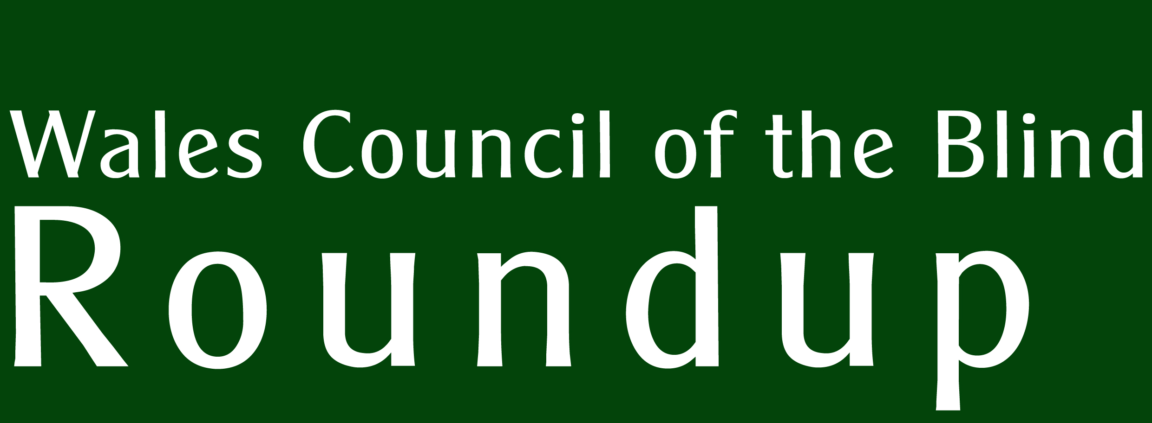 | Supported by  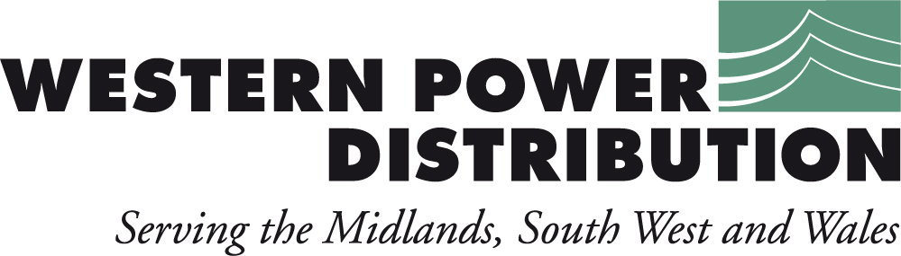  No. 29
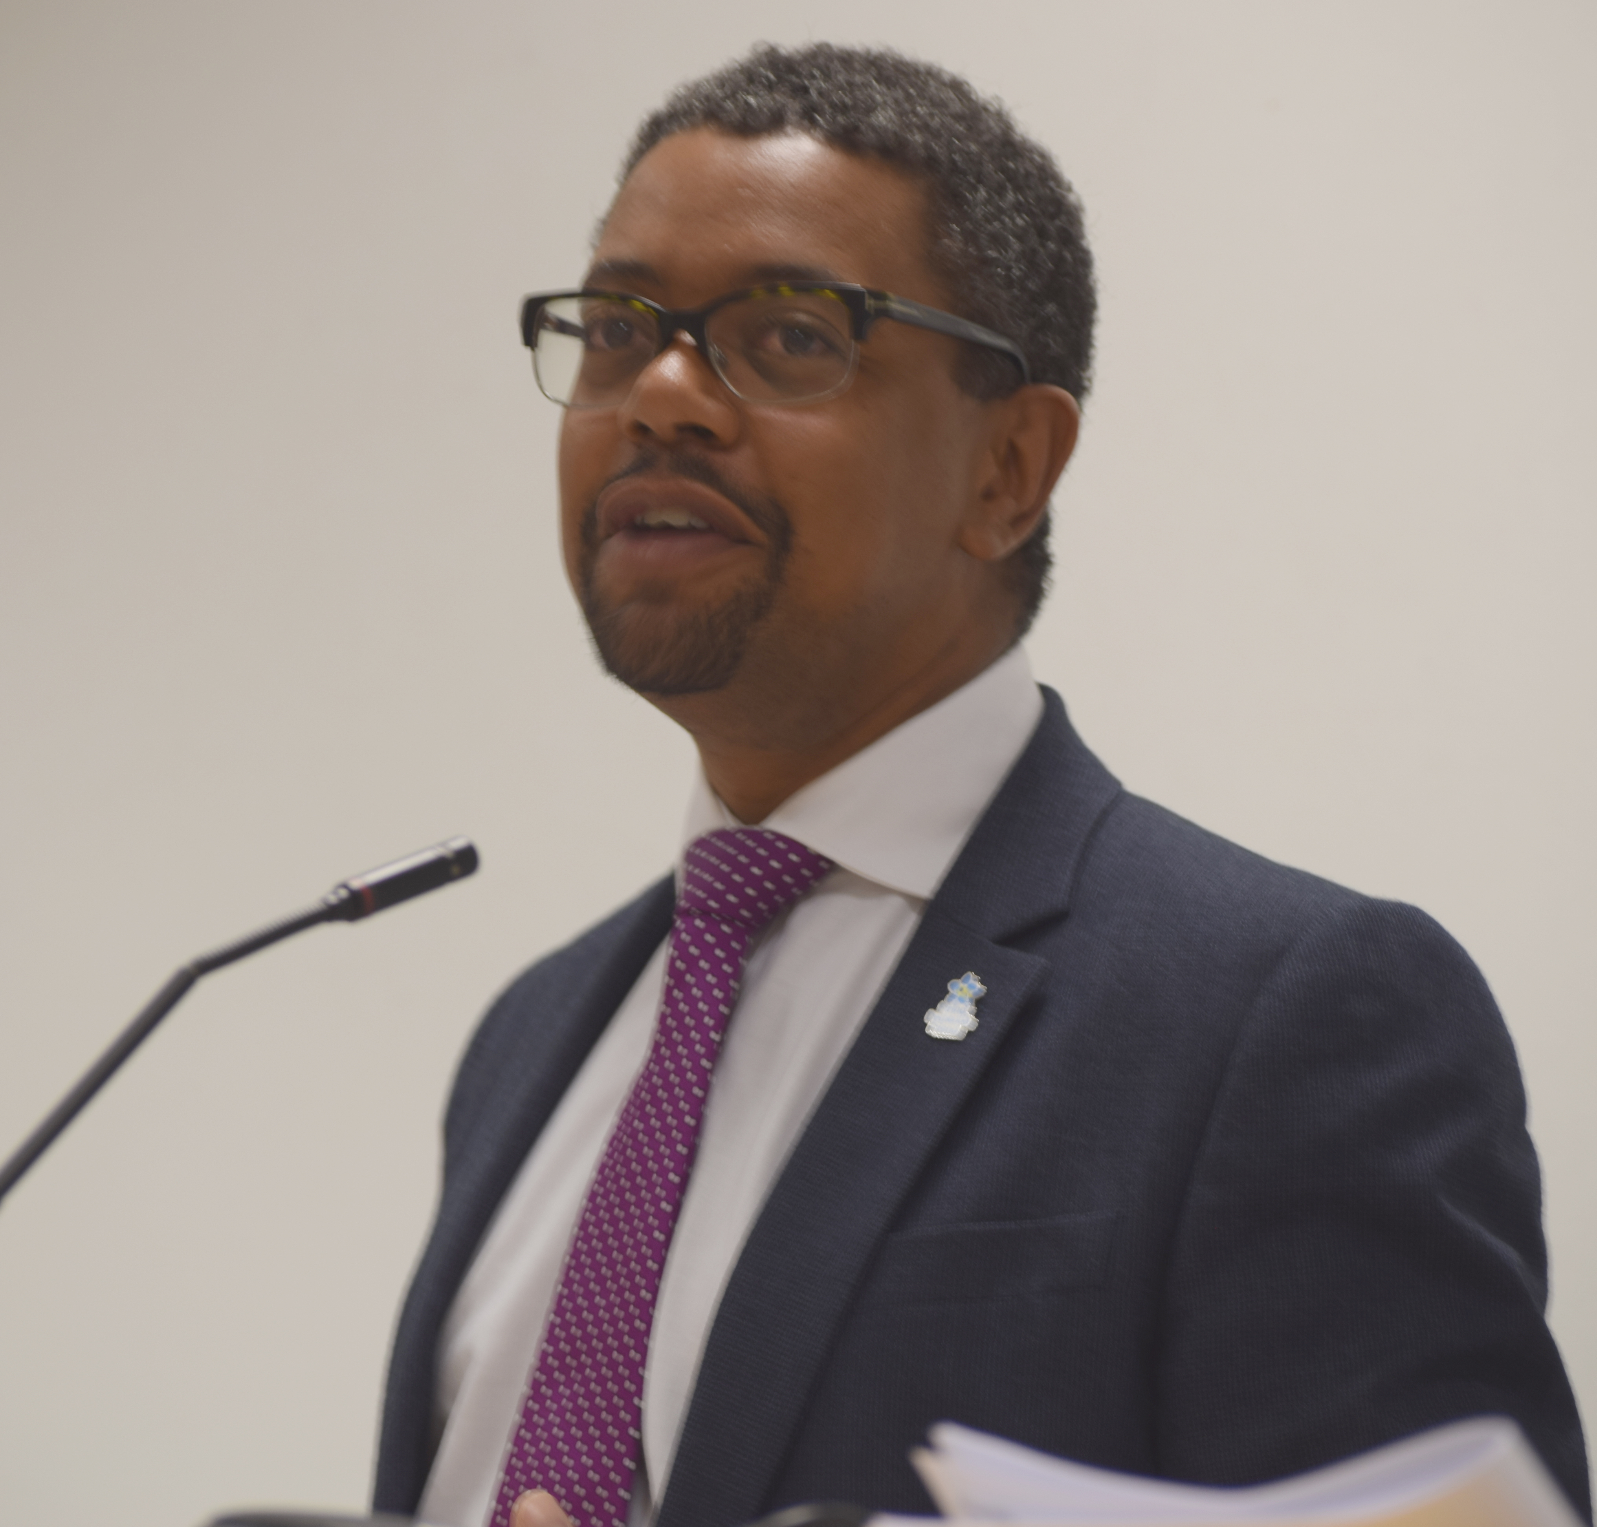
Wales Eyecare Conference 2017
Perspectif Supplement: Condition-Specific Support

Delivering electricity to homes and businesses is about more than just cables and wires, poles and pylons. It’s about providing people with a service that they can depend upon to help them live their lives to the full.
At Western Power Distribution we are investing many millions of pounds long-term on our electricity network to ensure all our customers continue to receive the same world-class service.
We are proud to be leading the way in terms of customer service, network reliability, technical innovation and environmental care, but we are not complacent. This is why we will continue to set our own demanding performance targets and exceed those set by our industry regulator.
Our Target 60 initiative is a case in point, for when power interruptions occur its aim is to restore supplies within the first hour. This is a commitment our customers can depend upon.
To find out more about our plans for the future visit www.westernpower.co.uk or email info@westernpower.co.uk.
If you have a power cut – call our new emergency number 0800 6783 105
EDITORIAL

Welcome to the latest edition of Roundup. It’s a bit lighter than usual. That’s because there’s another edition of the Perspectif Supplement accompanying Roundup this quarter. The Perspectif Supplement is an occasional extra that gathers information on a particular topic from WCB’s Perspectif Online Portal, and adds in articles written by individuals and organisations to enrich the content. This quarter’s edition looks at specialist organisations supporting people with specific eye conditions including self-help groups.

In Roundup, as guest contributor, John Sanders writes a piece exhorting those of us with sight loss to ‘own’ our sight conditions – sharing and discussing helps us to understand that we are not alone and we can equip ourselves to explain things to inquisitive friends and workmates. Specialist groups can make that dialogue happen.

I hope you enjoy this edition. The theme for our next edition will be vision impairment awareness (including awareness training). If you know of any sources of information on this theme, please get in touch.

- Richard Bowers

WCB Roundup is published quarterly by Wales Council of the Blind, 2nd Floor, Hallinans House, 22 Newport Road, Cardiff CF24 0DB. Tel: 029 20 473954.
Email: richard@wcb-ccd.org.uk.

Further copies, in audio CD or large print formats, are available. All editions are online at
http://www.wcb-ccd.org.uk/roundup.php

Advertise in WCB Roundup
WCB Roundup is sent to more than 2500 people, in a variety of formats. We are a not-for-profit organisation that hopes to recoup its costs. We seek advertisers for our newsletter so that we can continue to produce this valued journal. Advertisers will reach a readership of individuals with sight loss, optometrists, ophthalmologists, rehabilitation officers, social workers, and organisations working for blind, partially sighted and disabled people.

Our rates are (per edition):
Full A4 page: £150 (black and white) £250 (colour)
1/2 A4 page: £100 (black and white)
Enclosures: single sheet A4, supplied in a ready-to-go format: £200. Ask for quantity required.
Larger enclosures (such as booklets): please ask for quote.

To advertise in many editions, please contact us for discounts. Contact Ann via ann@wcb-ccd.org.uk or
telephone 02920 473954.
Owning up

by John Sanders, guest contributor.

The questions my school-friends asked were perfectly reasonable. How did my eye condition affect what I saw? Why didn’t glasses fix it? Would it get worse? What caused it? Embarrassingly, I couldn’t answer them because I didn’t know myself. I wasn’t even sure what my eye condition was called. And this was despite 16 years of regular appointments in at least four eye hospitals.

Although my teenage friends of the 1970s didn’t realise it, their curiosity set me on a quest to find the answers to those questions. From what doctors had said to my parents I vaguely knew there was little prospect of a cure. But my friends’ natural curiosity had shown me that I didn’t have many options. My eye condition (nystagmus) wasn’t going away. I couldn’t hide my flickering eyes. So I might as well find out everything I could and learn to live with it.

In the pre-Internet age, though, finding answers was difficult. The breakthrough finally came during a routine eye test in my mid twenties. The optometrist mentioned a possible treatment in the nearby London Refraction Hospital (now the Institute of Optometry). The treatment didn’t work, but what I learnt from the hospital staff and from others with the same condition was life-changing.

A problem shared is a problem halved.
We swapped tales of awful school days (PE teachers were a common target of our ire). We commiserated about not being able to drive, about struggling to see bus numbers, menus and train timetables. And we made several surprising discoveries.

Firstly, by sharing the daily challenges we faced we were able to laugh and even joke about having poor vision. Secondly, by comparing notes we learnt things about how nystagmus affected us that, individually, we were often unaware of. Thirdly, I think we all felt better and more confident for having talked about our shared disability.

Looking back now, that point in my mid twenties was when I began to take ownership of my vision impairment. By ownership I mean understanding how it affected me so that I could talk about it when I chose to. At last I could answer the questions friends and colleagues had. And I could explain my condition, when necessary, to employers or even strangers.

Boring for Britain.
As a result, nowadays I feel much less a victim of my disability. I no longer dread questions about what I can or cannot see. In fact I welcome conversations that start: “I hope you don’t mind me asking about your eyes ...” or “This may be a silly question but ...”. I can, and I’m sure I sometimes do, bore for Britain on the subject.

Yet quite a few vision impaired people I meet know little about their condition or are reluctant to talk about it. That can lead to awkward situations with friends, family and colleagues. And it probably won’t improve your chances of getting a job or promotion either.

Talking about being vision impaired is not easy. Even for me now it can be hard to judge when to broach the subject and how much to say. But at least I know the answers to the questions my teenage friends asked all those years ago and I’m not afraid to answer them. And for that I am very grateful indeed.

WCB NEWS
Your Voice: a Shared Vision.

West Wales Regional Forum

At the September meeting the group heard a talk from Eryl Williams of the International Glaucoma Association about the importance of ensuring children are screened for glaucoma at the earliest possible age. This can be carried out by an optician. Also, people who have been prescribed drops must maintain the correct application of this medication for life – 40% of 27,000 glaucoma patients in Wales fail to do this and are putting their eyesight at serious risk.

Maddy Roberts – a volunteer for the Macular Society – explained her role as an assessor and advisor to people who share her condition. She talked about the strategies that can help to enable activities like reading. She also stressed the importance of open communication so that family members and friends can understand macular disease and its effects.

Matthew Mathias from the Electoral Reform Society brought the room alive by stimulating a debate on what we think of the state of politics. He also inquired about the barriers to accessing the voting system and the threats to privacy that can arise when using the solutions provided at polling stations.

The next meeting will be announced at a later date. Please contact Rebecca at WCB for more information about the West Wales and South-East Wales Forums on
029 20 473 954 or email bec@wcb-ccd.org.uk.

South East Wales regional group

Universal Credits and GP preferred formats, were some of the topics of discussion at the September event, followed by an update from Megan John, WCB's Young Adults Project Officer.

Universal Credits
Mike Rose, a member of the group, gave a brief report after attending a recent presentation. Universal Credits will be replacing Child Tax Credits, Housing Benefit, Income Support, Income-based Jobseeker's Allowance, Income-related Employment and Support Allowance and Working Tax Credits. The Universal Credit Full Service is being introduced in stages across the UK. It has been rolled out in some areas of Wales already and will continue to do so over the coming months. Further information is available on the Government website: https://www.gov.uk/universal-credit.

GP Preferred Formats
Owen from WCB informed the group that patients can now request communication in their preferred format from GP surgeries and urged everyone to do so.

WCB's Storm project
Megan John gave an update on WCB's Young Adults project. In collaboration with UCAN Productions, they recently performed at the Welsh Government's Annual Wales Eyecare Conference in Cardiff. The theme this year was 'Accessibility' and the team were asked to create two thought-provoking sketches. A full report is available in their newsletter 'Storm'.

For more on StormWCB, please read the supplement attached.
ACROSS THE SECTOR

Outcomes and Accessibility: Annual Wales Eyecare Conference 2017

Again, the Eyecare Conference, held during National Eye Health Week, attracted a full house at the School of Optometry and Vision Science in Cardiff. Fiona Jenkins opened and chaired the conference and highlighted some of the priorities for Eye Health Care Delivery Plan in the coming year, identified through workshops at last year’s conference.

Vaughan Gething AM, Cabinet Secretary for Health, Wellbeing and Sport, gave the keynote speech and also reflected on these priorities and highlighted the achievements of the sector.

These achievements were also relayed from the Local Health Boards in a series of quick-fire reports from each LHB. Virtual clinics in Aneurin Bevan were talked about as were the e-Optometry referral pilot from Cardiff and Vale.

The problems of accessibility were dramatised in two thought-provoking performances by members of Storm WCB/UCAN Productions. Their sketches focused on the problems of poor access to health care and what goes well when things are right.
This year there was a focus on services for children in Wales where the audience heard about the Qualified Teachers for the Visually Impaired; the habilitation role; the school pupil eye care service pilot; the vision screening pathway; and Dr Heather Payne talked about some of the successes across the sector.

Delegates heard talks on the Social Services Act and population needs assessments and what they mean for people with sight loss and deafblind people.

Alongside the All-Wales Standards for Accessible Communication and Information for People with Sensory Loss is the It Makes Sense campaign which asks patients to tell, ask and share. Tell doctors, nurses, paramedics and other health professionals how you prefer to communicate; ask to receive information in the format you prefer; share your concern if you do not receive this. Tracey Good and Marcia Morgan spoke about the priorities within the standards, developing staff awareness and workforce engagement; recording and flagging patients’ communication and information needs; accessible appointment systems that enable patients to communicate in a variety of ways including texts and emails.

The way hospitals communicate is a concern for Ziad Khan, who delivered the patient voice to the conference. He explained what accessibility means to him and how simple things like appointment reminders via text, that his hospital do not currently provide, would make a considerable difference to him.

Mike Austin and Graham Shortland gave a joint presentation on Prudent Eye Care and Clinical Prioritisation. (There is an article about this below).

Next year’s conference will take place during the 70th Anniversary of the NHS so we can expect there to be a review of changes and improvements to eye care services over this period.

Care for those with the greatest health need first – reconciling risks and waits in Hospital Eye Services.

Michael Austin and Graham Shortland delivered a presentation to the Welsh Government Annual Wales Eyecare Conference (see above) that addressed the problem of the waiting lists for follow-up appointments in ophthalmology. “In Wales, the Hospital Eye Services (HES) have tended to accumulate patients with [...] chronic conditions that need ophthalmologist supervision of care but for whom review appointments have been relatively unavailable. Such problems of demand-capacity mismatch affect much if not all of the NHS in the UK.”

They warn of the impact of the current system that favours Referral to Treatment Time statistics. “In common with others working in eye health care, ophthalmologists have been concerned for some time about the dangers inherent in systems for allocating outpatient appointments for patients who are new referrals in preference to those being followed-up. Patients with little risk of permanent adverse outcomes have been seen ahead of review patients at greater risk. This is wrong.”

They argue that the system needs overhauling along the lines of the Bevan Commission’s Prudent Healthcare proposals so that “patients needing eye care are seen within a clinically relevant and appropriate timeframe where patient outcome and experience are paramount”. In other words, patients are allocated appointments according to clinical need, not merely to meet easily won performance targets.

This is a popular proposal, arrived at through consensus across a range of interests and expertise, including patients. It hopes to achieve better outcomes and equity of access to care for patients of equivalent need, better risk management where capacity and demand don't match up, and better data to aid service planning.

Welsh Government's Eye Health Care Delivery Plan for Wales talks of revising targets for ophthalmology to incorporate measures that include follow-up patients based on clinical need and risk of irreversible sight loss. This is welcomed by the profession since “the lack of minimum standards for follow-up patients against the precedence of targets for new patients has been recognised [...] as disadvantaging large numbers of patients with Wales' most common causes of sight impairment”.

After explaining the inter-relatedness and distinctness of the terms ‘urgent’ and ‘priority’, Austin and Shortland outlined the three priority definitions agreed by the New Measures project:

1. Patients who may suffer serious irreversible harm from delayed appointments;
2. Patients who may suffer reversible harm from delayed appointments;
3. Patients who may be inconvenienced or suffer mild and / or reversible consequences from delayed appointments.
Examples could be diabetic retinopathy undergoing a course of treatment being classed as Priority P1, most cataract operations as Priority P2, and most benign eyelid lesions as Priority P3.

“There will be special cases from time to time. This scheme is meant to deal with the great majority of patients for purposes of service planning”. The important shift in the thinking is that “status as a ‘new’ or ‘follow-up’ patient has no bearing on the level of clinical priority”.

The Cabinet Secretary for Health recently stated “I accepted that our current measures probably don’t give us the fullest reflection and assurance. That’s why work is already ongoing with a pilot that is due to start this autumn in two health board areas—in ABM and in Betsi—looking at what we could do to have a new set of measures to drive more appropriate clinical behaviour. We’ll then have a better understanding of the risks we are carrying in our system, and a proper identification that does look at follow-ups where it’s clinically appropriate to do so. So, we’ll have a system that I think will make more sense”.

Cerebral Visual Impairment Society Convention 2017

John Sanders reports from the CVI Convention.

The 130 delegates in Bristol for the CVI Society’s third annual convention were split almost evenly between professionals and families affected by the condition. And so was the programme which featured young people with CVI, notably Sophie and Art, as well as parents, researchers and teachers.
In an entertaining update, Sophie (an ambassador for the society) spoke about her recent experiences with the National Youth Theatre. One of her future ambitions is to become the first disabled woman to play the title role in the BBC TV series “Doctor Who”. As Sophie points out, that’s the next logical step now that a woman is about to take on the Doctor Who role for the first time ever. Sophie blogs about her life (see https://www.cvisociety.org.uk/single-post/2017/06/28/Sophies-blog-3-Life-after-treatment) and is an inspiring role model for parents of children with CVI.

Similarly, fellow ambassador Art’s ambitions in the world of IT show that there’s no need for CVI to hold young people back. Art also spoke about the difference that finally being epilepsy free makes to the quality of his life. He’s now much more independent and mobile, but has to be particularly careful when crossing roads.

CVI patron and ophthalmologist Gordon Dutton explained some of the subtle ways that CVI affects vision. It’s often difficult for people with CVI to take in visual information in busy, cluttered or fast moving environments. Professor Dutton used the analogy of learning French. Ask a native speaker to talk slowly and it’s amazing how much more you can understand. It’s just the same with CVI – more time and less clutter makes it much easier to see.

Richard Bowman, an ophthalmologist in London’s Great Ormond Street Hospital, said professional awareness of and interest in CVI is growing. One sign of this was a CVI research project winning a prize at the BIPOSA ophthalmology conference in Hull this year. Bristol ophthalmologist Cathy Williams spoke about her work on quality of life for people with CVI and invited people to take part in research by emailing cvi-project@bristol.ac.uk.

Partial loss of visual fields is common to people with CVI. So Professor Paul Chung demonstrated a prototype system using virtual reality goggles. This shows other people what it’s like to walk around when, for instance, you can’t see where your feet are going.

Parents spoke too. Mum and TV producer Melissa expanded on the theme of clutter and how cutting back the layers of detail in television images in sound could benefit people with CVI – and many others too. Tony talked of the frustration of not being able to get support for his son in school because the traditional way of testing vision based on visual acuity – reading letters on a chart – doesn’t pick up the visual difficulties his son faces.

Challenging outmoded practices was a theme running throughout the convention. Several speakers noted that the emotional and social consequences of CVI are often underestimated. And at the very outset, CVI chair Janet Harwood (who is also a QTVI qualified teacher of the visually impaired) emphasised the importance of “following what works for the child - even if it doesn't fit with accepted teaching methods.”

CONSULTATIONS
Welsh Government
Details of all consultations are at http://wales.gov.uk/consultations. This is particularly relevant to our sector:

- Mandatory concessionary fares scheme in Wales (closes 12 January)

For preferred formats contact CustomerHelp@wales.gsi.gov.uk or call 029 2082 3683.

OPPORTUNITIES

Change 100 for disabled students

Once again, Leonard Cheshire Disability is running its ‘Change 100’ scheme, which offers work placement opportunities with top UK businesses to students with a disability. To date the charity has placed over 250 interns with over 90 employers across the UK and is looking forward to partnering with even more organisations next summer.

Disabled students in their penultimate or final year, or who graduated in 2016 or 2017 are invited to apply for three-month placements in summer 2018. Successful applicants get mentoring and guidance throughout their paid placement, to help them excel and thrive within the workplace.

For more information on the scheme and how to apply, visit the Leonard Cheshire website, https://www.leonardcheshire.org/support-and-information/latest-news/press-releases/top-businesses-help-disabled-students-kick-start. Applications must be received by 24th January 2018.

Try bowling in Llanelli

Llanelli's Vision Impaired Bowling Club is looking for new members. The club meets every Tuesday from 12 midday to 3 pm at the Selwyn Samuel Centre, Park Crescent, Llanelli. Helpers would also be very welcome. For more information, contact Stephen Ricketts 07582 647740.

PUBLICATIONS AND RESOURCES

Resources for teachers

Undiagnosed sight loss may explain underperformance in the classroom, so the Macular Society has produced a range of resources for teachers with vision-impaired students helping them make lessons more accessible.

Topics covered include tips for teaching maths, history, art and sport, as well as general teaching advice, and guidance on school trips. You can find these resources on the Macular Society website, https://www.macularsociety.org/teaching.

Guide to Stargardt Disease

The Macular Society has produced a new leaflet on Stargardt disease, the most common form of juvenile macular dystrophy which causes a wasting of a central area of the retina.

'Your guide to Stargardt disease' covers topics such as symptoms, diagnosis, the deterioration of vision, treatments and support. You can read the leaflet on the ‘Resources’ section of the Society’s website: https://www.macularsociety.org/resources.

Transition to adulthood

The Longitudinal Transitions Study is a research project following the experiences of young people with vision impairment during the transition from school through to employment and adulthood. The research has been carried out by the Vision Impairment Centre for Teaching and Research (VICTAR) at the University of Birmingham, in collaboration with RNIB and supported by the Thomas Pocklington Trust. A series of resources based on the project has now been published.

These include guidance for young people going to university, a guide for parents and a 'learner outcomes framework'. For more information and a link to all the resources, visit the Thomas Pocklington website, http://www.pocklington-trust.org.uk/project/transition-empowering-visually-impaired-young-people-move-adulthood/.

Sense employment guides

Sense, the organisation for people with dual sensory loss, has carried out research into the barriers which face deafblind people who are looking for work, and produced three employment guides to help address some of the issues raised.

The guides are:

- 'A guide for employers', which gives an introduction to important things they should be aware of when employing someone with sensory impairments.
- 'I want to work - an employment guide for people with sensory impairments' provides information, guidance, and useful resources for people with sensory impairments who are both looking for work or currently employed.
- 'Employment factsheet for healthcare workers' contains information to raise awareness of deafblindness, and outlines the support available when someone who is deafblind wishes to work.

Much of the information is equally applicable to people who have a vision impairment, but not hearing loss. The full report and the three guides can be found on the Sense website, https://www.sense.org.uk/content/employment.

Nystagmus Information Pack

The Academic Unit of Ophthalmology and Orthoptics at Sheffield University has developed a Nystagmus Information Pack, with support from the Nystagmus Network (NN), and input from people attending NN events. The resource was launched on 'Wobbly Wednesday', the annual event which raises awareness of this eye condition.

The information is intended for patients with nystagmus, families, teachers, other professionals and people who would like to find out more about the condition. It covers topics such as infantile and acquired nystagmus, what to expect at eye clinic appointments and treatment options.
We have put a link to the information pack on our website, http://www.wcb-ccd.org.uk/single_post.php?var=2205.

Roundup distribution

We have recently increased our readership thanks to an arrangement with Vision Impaired West Glamorgan where we produce an edited version of Roundup to accompany their Vision News quarterly. WCB helps with the printing and distribution of their newsletter and we get to share Roundup with their subscribers.

We have slightly different arrangements with two other organisations, Visual Impairment Merthyr and Radnorshire Association for the Blind.

We are keen to extend our readership in partnership with similar organisations, so please get in touch if you would like to be involved. Contact richard@wcb-ccd.org.uk or ring
029 20 473954 for more information.
Power for Life
Western Power Distribution (WPD) operates the electricity distribution network in the Midlands, South Wales and the South West. Put simply, our role is to ensure the power network of poles and pylons, cables, wires and substations – the infrastructure that we all rely upon to live our lives to the full – delivers electricity to our homes and businesses around the clock.

Power cut? Call our emergency number 0800 6783 105
Sometimes power cuts can happen for reasons beyond our control. During a power cut we are able to help.
We know it can be particularly worrying if you rely on electricity for medical equipment or if you are elderly, very ill or disabled. If you depend on electricity for a reason such as using a nebuliser, a kidney dialysis machine, an oxygen machine, a ventilator – or any other reason – you should register with us.
WPD provides a FREE Priority Service Register, which helps us to identify customers who may need a little extra help during a power cut.
If you join our FREE Priority Service Register we can:

- Give you a direct number to call in the event of a power cut so you can get straight through to us.
- Agree a password with you before we visit you, so you feel safe.
- Provide special help, if needed, through the RVS (Royal Voluntary Service) or British Red Cross.
- Ring and tell you about planned interruptions to your electricity supply.
- Keep you as informed as possible in the event of an unplanned power cut.

To join, call 0800 9177 953, or visit our website www.westernpower.co.uk
EVENTS

Have a Go weekend at RNC

Royal National College for the Blind (RNC) in Hereford is organising a ‘Have a Go’ weekend for young people with a vision impairment aged 13 to 17 year on 17th and 18th February. There will be an opportunity to try a range of activities including goalball, bowling and the performing arts. The event is free and includes overnight accommodation.

For more information and to book a place, visit the RNC website, http://www.rnc.ac.uk/events/haveago, telephone 01432 376 621 or email info@rnc.ac.uk.

Specialist Workers Meeting

Sight Cymru is arranging a Specialist Workers Meeting at the Masonic Lodge, Masonic Hall, Cardiff on Friday 23rd March 2018. The programme for the day will be:

12.00 Registration
1.00 pm Habilitation Specialists Sarah Hughes / Adrian Linney
1.30 Lunch and networking
2.00 Ms Rita Sengupta, Consultant Ophthalmologist, Diabetic Retinopathy
2.30 Mr Gwyn Williams, ‘Crest of the diabetic tsunami’
3.30 Open discussion on prevention of diabetes
4.00 Close

To book a free place contact Lissa Gomer at Sight Cymru, on 01495 763650 or by email at lissa.gomer@sightcymru.org.uk.

Gower Sensory Walk

A 'Gower Sensory Walk and Land Rover Safari' designed for vision impaired people and their friends will be held on Friday 8th December from 10 am to 4 pm (meet at Cwm Ivy Car Park, Gower). The walk will include the Worm’s Head where you will meet the volunteers who keep the lookout, and a chance to learn about the medieval field system that’s being restored to help feed wild birds and to experience the dramatic scenery. The Land Rover safari will take you to the salt marsh and beach at Cwm Ivy to find out about the lighthouse and experience the world of the wild geese. National Trust wildlife rangers will be on hand to unlock the secrets of the fascinating flora and fauna. Also guiding on the walk is vision impaired artist, Chris Tally Evans, who will invite you to participate in his community arts project Gŵyr Gower: Almost an Island.

To book one of the 4 places reserved for vision impaired people (over 16 years of age) or the 4 places available for guides / friends please ring the National Trust office on 01792 390636 or email christallyevans@gmail.com.

Applying to University Course

New College Worcester (NCW), in association with VICTA, is running a course for young people with a vision impairment who are applying to attend University in 2019, and their parents. The free, residential event will be held on 28th and 29th March 2018.
It will cover a wide range of topics, including how to choose a course, choosing a University, student finance, independent living and sources of support. For more information and to download an application form, visit the ‘Events’ section of the NCW website, http://www.newcollegeworcester.co.uk/events, or telephone 01905 763933.


