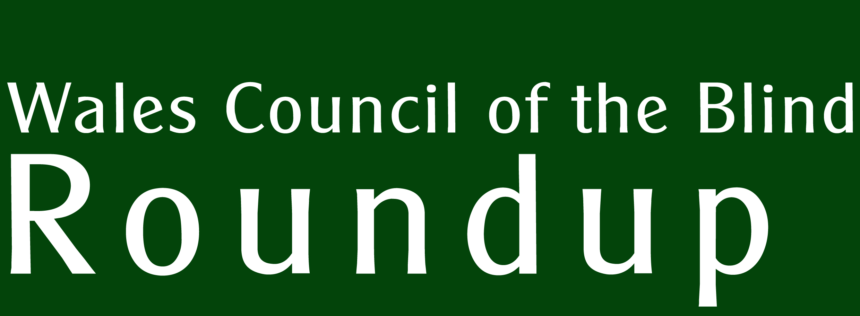 Summer 2015
Celebrating 10 years of UCAN Productions

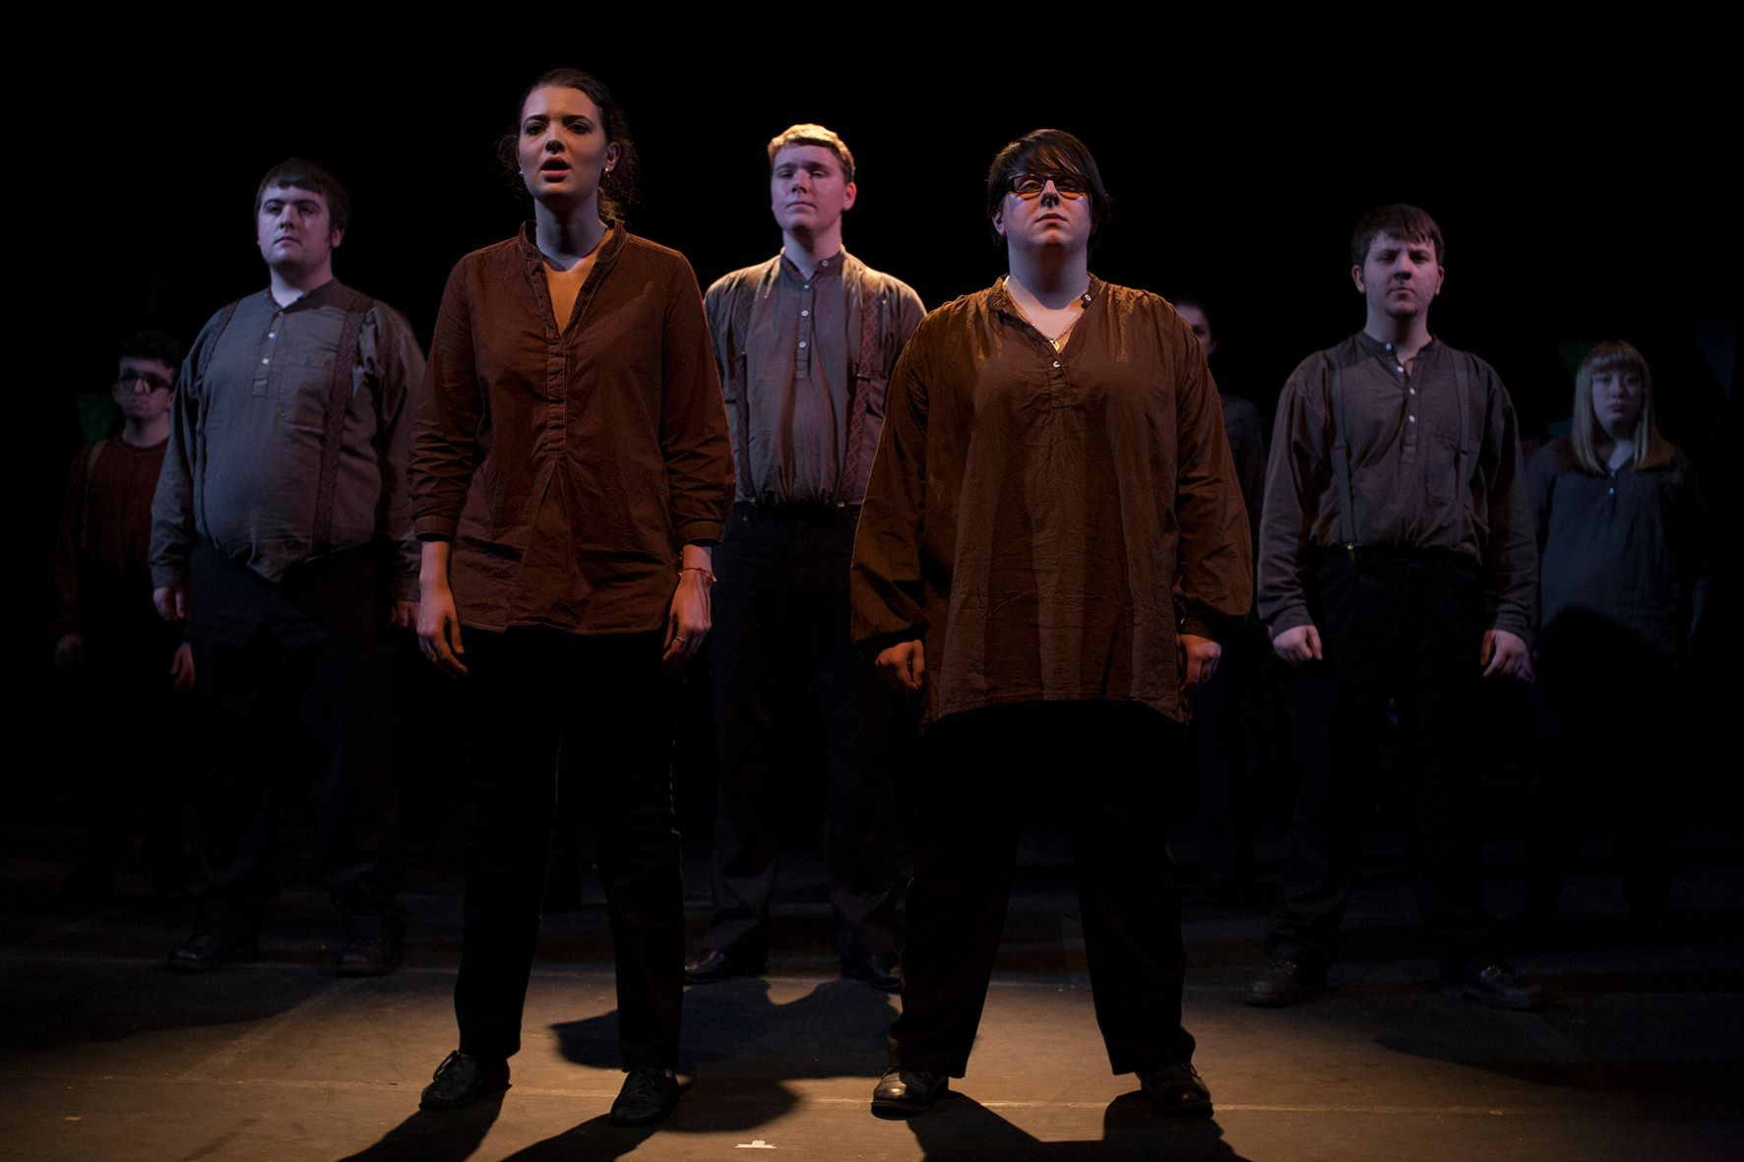

Plus launch of WCB Perspectif - conference reports – 150 years of Sight Cymru

Supported by
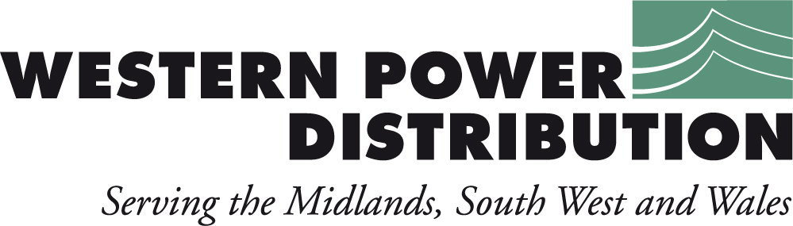
Richard Bowers reports on the Wales Vision Strategy Conference and Sight Cymru’s Wales and West Conference

The World Outside - WVS Conference 2015

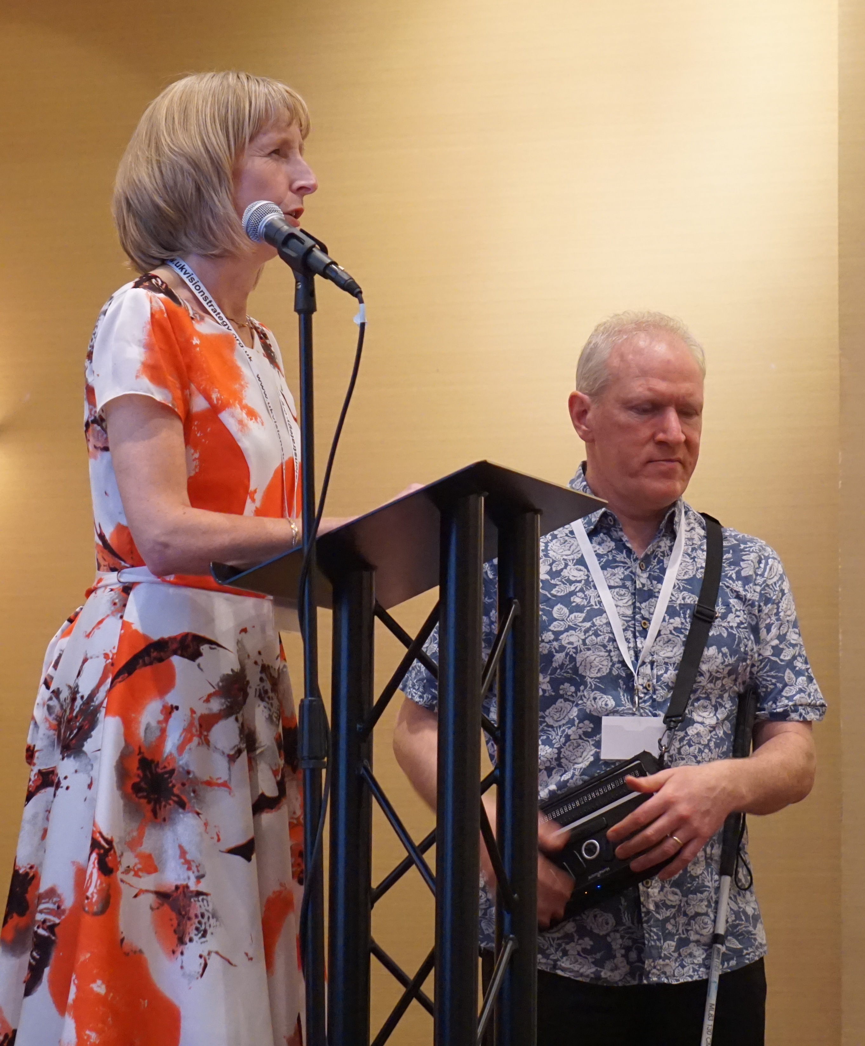
The Wales Vision Strategy, allied to the UK Vision Strategy, was re-launched last year with a new strategy for 2014-18. This year’s conference took a look at ‘The World Outside in 2030’ where information technology and the development of accessible environments and transport should transform the lives of disabled people. The conference’s tone was set by Andrea Gordon and John Ramm (pictured) who gave their accounts of how technology – currently, at least, - cannot be completely relied upon to make the world a safe place if you can’t see it. Andrea feels that ‘one of the biggest challenges in my work is how independent I can be – on my own. I want to know that I can go out shopping, meet my mates, go to the pub without help’.

But, as John Ramm explained, the problem with using devices such as GPS systems is they don’t take account of the myriad obstacles in the urban environment. They may well tell you the street you are on and direct you to the next street but railings, overhanging branches, crossings, bin bags, street furniture and so on are not accounted for.

This may be set to change following the development of new devices. Jenny Cook, of Guide Dogs, spoke about the Cities Unlocked project. Cities Unlocked draws on the expertise of Future Cities Catapult, Guide Dogs and Microsoft. “We've come to understand the mobility challenges faced by people with sight loss in our cities. In response we've developed a new soundscape technology and highlighted further opportunities for innovation that could unlock cities for everyone.”
John Worsfold, of RNIB, gave an update on smart glasses that help wearers identify shapes, determine distance, and are able to detect objects up to three metres away.

In the meantime, we depend upon the good work of people like Rob Gravelle whose role includes ensuring accessibility is built into the planning of the urban environment. ‘Why should we exclude disabled people?’ he asked. At Cardiff Council he encourages engagement with users and stakeholders to help build a body of expertise to shape urban planning decisions.

Sandy Mewies AM added a note of realism: ‘I don’t think we can ever fully succeed in equalities. We just have to keep our eye on the ball and do our best to see that it happens.’

http://www.citiesunlocked.org.uk/
http://www.rnib.org.uk/smart-glasses

Wales and West Conference - Vision after Stroke.

At every conference we are reminded that sight loss is not an isolated phenomenon – it often operates alongside, or is caused by, other medical conditions and can go undiagnosed due to it being masked by other symptoms - symptoms which may be more conspicuous or urgent to doctor and individual alike. We’ve been told of the link between learning disability and sight loss – learning disabled people are ten times more likely to have sight problems which can easily be overlooked, and an estimated 30% of people with dementia are likely to have serious sight loss. Today we learned that stroke is no exception.

After Ross Evans’ dynamically presented overview of stroke, some myth-busting and an exhortation to apply the FAST rule (Facial weakness, Arm weakness, Speech problems, Time to call 999) to self-diagnose a mini-stroke and to get it seen to immediately, we were given some detail about the impact stroke can have on vision and the rehabilitation measures that can make a difference if sight is properly diagnosed by an orthoptist.

Dr. Annegret Dahlmann-Noor told us about the three effects on vision that can come from ‘brainstorm stroke’: sensory (affecting the visual field); eye movement (causing, for instance, double vision or jumpy images); and processing (Charles Bonnet syndrome and palinopsia, where previously-received images may appear superimposed over the currently-perceived image).

Unlike Dahlmann-Noor, Dr. Holly Bridge made no concessions to the audience, articulating complex neuro-science to a non-medical audience. I could get this much: work with MRI scanning has revealed that the brains of individuals with hemianopia (where half of the visual field is obscured) can be stimulated by high contrast moving images in the ‘blind’ area of their vision. Interestingly, the area of the brain being used in these cases is a very primitive part that detects movement for survival purposes and is a region quite separate from the visual cortex, where ‘normal’ visual processing takes place. However, Bridge’s talk was tough to follow, despite being one of the more interesting ones.

Sonia McDiarmid closed the conference with an overview of the impact of stroke on sight. She spoke of a programme to routinely screen stroke patients for visual problems. 60% of stroke patients have some form of sight loss in isolation, or in combination. 15% of screened patients reported no visual problems yet, on closer examination by an orthoptist, were found to have some. Indeed, some patients may be twisting their heads or bodies to one side to compensate for a blind spot, yet do not see themselves as having a vision problem. The numbers of people with perceptual defects such as Charles Bonnet Syndrome are reported as low but, McDiarmid suggests, these figures may be under-reported for a variety of reasons, including a reluctance to talk of hallucination for fear of being diagnosed with mental illness.

So much for stroke. Two other presenters went their own way. James Morgan told us where the Open Eyes project stands currently and expressed his personal disappointment that it had not been given the green light in Wales. Open Eyes is essentially an open source IT system that enables unified diagnoses of patients in ophthalmology. Morgan has demonstrated its potential to link to high street optometrists to form a digital chain of information that takes in eye clinics and virtual clinics. It can also have data fed to it from manufacturers such as Zeiss and could be linked to both the electronic patient record and the electronic certificate of visual impairment (eCVI) system. He has it running in Cardiff and Vale LHB and he pointed out that most of London is using it, along with other locations in England. His complaint is that the rest of the world is investing heavily in IT solutions – banking and retail, for instance – yet health is woefully lagging behind.

Mike Brace, former head of Vision2020, gave us his personal take on how things have changed in healthcare in his lifetime. In the early days he felt that professionals were ‘doing things TO him’ whereas patients are now regarded as consumers of services. Yet he still doesn’t feel that he’s at the centre of the processes set up to provide his healthcare. He has seen changes in the way children are dealt with: they used to be treated like ‘adults, but slightly younger’. Now, in some areas, habilitation is offered to children rather than rehabilitation. But, he feels, it still remains that ‘sight loss is the Cinderella of services’ and we must continue to fight to get it on the agendas of every area that has overlooked it.

Some great resources were pointed out during the day. ‘Be my eyes’ (www.bemyeyes.org) is an internet service on iphones and ipads where you can contact a volunteer who will interpret what is visible to your iphone camera. The volunteer will tell you if the tin you are holding up is baked beans or cat food, for example. www.eyesearch.ucl.ac.uk is an online tool to improve the visual function (as opposed to visual field) of people with sight loss caused by brain injury, such as hemianopia.
Proposed regional maps of Wales

We finally get to see what the local authority map will look like after Leighton Andrews, Public Services Minister, presents merger plans at the Welsh Local Government Association conference.

It looks rather like Wales in the pre-unitary authority days of Dyfed, Gwynedd, Clwyd, Powys, Gwent and South, Mid and West Glamorgan. The area still under debate is in the North, where two options are proposed: one where Conwy merges with Gwynedd and Anglesey, forming 8 Welsh authorities in total; another where Conwy and Denbighshire form an additional authority, creating 9 in total.

The change, estimated to happen around 2020, is intended to maximize resources across existing authorities.

Russell Goodway, former Leader of Cardiff Council, welcomes the proposal, arguing that eight individuals will have a greater ability to hold Welsh Government to account.

WCB shall follow with some interest how these boundary changes will affect Social Services across Wales over the coming years.

The likely groupings shall be:

Region 1: Monmouthshire, Newport, Torfaen, Caerphilly, Blaenau Gwent.
Region 2: Cardiff, Vale of Glamorgan.
Region 3: Bridgend, Merthyr, RCT.
Region 4: NPT, Swansea.
Region 5: Pembrokeshire, Carmathenshire, Ceredigion.
Region 6: Powys.
Region 7: Gwynedd, Anglesey (Conwy).
Region 8: Flintshire, Wrexham, (Denbighshire).
(Region 9: Conwy, Denbighshire.)
Celebrating 10 years of UCAN Productions

UCAN Productions has been in existence for a decade, building physical and vocal confidence in children and young people with sight loss. For this edition, we have included an audio CD highlighting UCAN’s work.

To celebrate their 10th year, UCAN is putting on a number of shows including ‘Palais de Danse’ at the Sherman Theatre (13th, 14th and 15th August), and two UCAN Perform Festivals at the Torch Theatre and the Wales Millennium Centre on the 14th and 28th of July respectively.

The Torch Theatre and Millennium Centre were both pilot venues for the UCAN GO app, giving partially sighted and blind visitors a means of getting around the venue via live information provided through a smartphone.

On the CD, Lloyd Coleman with friends and colleagues reflects on 10 years of creativity with UCAN, their achievements, and how the lives of young people with sight loss have been changed. And we’ll get to hear a small selection of music performed by their talented artists.

Get in touch with UCAN:
Tel: 029 2087 0554 or 07812 051815
Email: info@ucanproductions.org
Post: UCAN Productions, PO Box 290, Cardiff, CF11 1NF.
Power for Life

Western Power Distribution (WPD) operates the electricity distribution network in the Midlands, South Wales and the South West. Put simply, our role is to ensure the power network of poles and pylons, cables, wires and substations – the infrastructure that we all rely upon to live our lives to the full – delivers electricity to our homes and businesses around the clock.

Power cut? Call our emergency number 0800 6783 105
Sometimes power cuts can happen for reasons beyond our control. During a power cut we are able to help.
We know it can be particularly worrying if you rely on electricity for medical equipment or if you are elderly, very ill or disabled. If you depend on electricity for a reason such as using a nebuliser, a kidney dialysis machine, an oxygen machine, a ventilator – or any other reason – you should register with us.
WPD provides a FREE Priority Service Register, which helps us to identify customers who may need a little extra help during a power cut.
If you join our FREE Priority Service Register we can:

- Give you a direct number to call in the event of a power cut so you can get straight through to us.
- Agree a password with you before we visit you, so you feel safe.
- Provide special help, if needed, through the RVS (Royal Voluntary Service) or British Red Cross.
- Ring and tell you about planned interruptions to your electricity supply.
- Keep you as informed as possible in the event of an unplanned power cut.

To join, call 0800 9177 953, or visit our website www.westernpower.co.uk
150 years of Sight Cymru

Sight Cymru celebrates its 150th anniversary this year. Chief Executive Sharon Beckett reflects on the organisation’s history.

Originally started by 3 church ladies in Newport, Sight Support Cymru has been running since 1865. In that time, it has moved from essentially being a ‘workshop for the blind’ in which basket weaving and tray making were the order of the day to a thriving charity that promotes independence in people with sight loss.

As with many local societies for the blind, for years we only gave out white canes and a cheque at Christmas, but in 1992 the organisation took on its first paid staff member, Pamela Dennis. It was agreed that funding would be sought for a resource centre and successful bids saw the first centre being opened in a warehouse in Pontypool. The organisation started to provide ‘rehabilitation for the visually impaired’ under contract for some of the local authorities, a role it has developed further as the years have passed.

A couple of near misses ensued with people attempting to reach that centre risking life and limb as they navigated between the fire service and the recycling tip lorries so further grant funding was sought to find a more suitable home. Bradbury Foundation, Torfaen County Borough Council and the charity’s own resources enabled the negotiation of a 99-year lease and subsequent renovation of three derelict cottages with a nice display of buddleia coming through the roof. No butterflies were harmed in the making of this programme.

Renovations were hardly straightforward, with various problems unearthed along the way, including an unexpected cellar (sadly no wine) and a resident ghost fondly named Harry by staff. Harry seems friendly enough, although there is something of a mass exodus in the winter months when it gets dark. One trustee meeting was halted when knocking was clearly heard on more than one occasion, but now that we know he’s friendly we expect Harry to join in on fundraising opportunities including our annual Halloween fest.

Not long after we moved to the new building, Bradbury House in the centre of Pontypool, Pam was awarded an MBE for services to charity, and chose that honour to step down and retire. She continues her involvement with the charity as a volunteer, and of course we couldn’t operate without our 100 volunteers who support the 22 staff in providing services for over 5000 people.

Further services have been gradually added over the years, including counselling, eye clinic liaison, conferences for service users and professionals and our Cats Eyes project in which we match people who are in need of company with furry 4-legged friends. We do much else besides – for more information visit www.sightcymru.org.uk or ring 01495 763650.

In our 150th anniversary year we have adopted the snowdrop as our logo and we plan to continue adding to our services over the next 150 years. Probably need a few new faces in that time though!

If you would like to visit, please do so – we are open to the public Monday to Friday from 9.30 – 4.30 and transport is available.

WCB News

Become a member of WCB

We are currently putting together our revised membership structure and the good news is that individuals with sight loss can join as a lifetime member for only £1!

Individual members will have a voice on one of the Regional Forums at which they can cast one vote. Each Forum is responsible for nominating one of its members to the Board of Trustees, so there is a real opportunity to get involved in the running of WCB as well.

If you would like to join, please contact Rebecca on 029 20 473954 or email bec@wcb-ccd.org.uk.

Shaping our lives and communities – planning together

Cathy Rogers, Project Officer for BCDP, gives an update on the Lottery-funded, Community Voice project.

A member said “As soon as I attended BCDP I knew they were a friendly and supportive group who really want to make a difference and as a result I have felt my confidence grow in a short space of time.”

Bridgend Coalition of Disabled People gives disabled people in Bridgend a platform to voice their views and experiences. Together we aim to make Bridgend Borough a more accessible place to live and work through a shared vision of the future with one voice.

This year BCDP have held three training sessions to give our members the skills, knowledge and confidence to become more actively involved in changing their community. Our first training session entitled ‘Disability Equality’ demonstrated how society puts barriers in place making it harder for disabled people to access independent living and what they can do to challenge it.

Our second training session entitled ‘Know your rights, use your rights’ taught our members what rights they had under the Equality Act 2010 and how they can use their rights when faced with discrimination.

Our final training session entitled ‘How to get involved in services’ showed our members how they can change services at ground level and how to make sure their voice has maximum force. Equalities and Engagement Officer, Paul Williams, was also present to demonstrate how the local authority makes decisions.

After attending all three training sessions one member stated, ‘I found this training package very interesting as now I know who I can contact with particular issues. It has made me more confident to challenge discrimination and highlight disability issues to service providers. I am excited to pass on my increased knowledge to other disabled people’

BCDP are continuing to hold our coffee mornings allowing our members to come together and talk about how they and other Disabled People can work together with public services to achieve our goals. We discuss what is and is not working well for Disabled People in Bridgend and seek ways in which we can get involved to change things at ground level. Our Evening Socials are also continuing to build our members’ confidence when accessing services in Bridgend and develop their skills through peer support.

This project is a collaboration between Bridgend Coalition of Disabled People, Disability Wales and WCB.

Contact: Cathy Rogers bridgendcoalitiondp@gmail.com
Perspectif – Wales’ Sight Loss Information Portal

The long awaited information portal, Perspectif, is finally available on-line and promises to be a central repository where you can find out about sight loss and services that support blind and partially sighted people throughout Wales.

People who lose their sight are often unaware of the support that is available to them to help restore confidence, independence or simply to enable them to maintain their lifestyle. Clubs, sports and leisure opportunities, social care, technical jargon, books and leaflets will all be highlighted in the portal, offering crucial help at a critical time.

Perspectif offers the option of a simple text search bar or a search where a personal profile can be entered to bring up a ranked list of services, organisations, terminology and publications. So someone with nystagmus living in Caerphilly, for example, can find relevant sources of help and guidance with ease.

The portal is free to use and by registering you can save items in a ‘folder’ for future reference. Professional users might also benefit from the ability to create multiple folders so that a number of virtual ‘service users’ can each have a folder.

An extra benefit comes from being able to produce a standard Rich Text Format document from any folder to print off or braille. This might be added to an individual’s case file or sent out as information to signpost a service user to local, relevant services. This document is editable in Word so can be customized for large print, font styles etc.

WCB sees part of its role as being the only national, independent organisation in Wales signposting professionals and individuals to services and support that make a difference to people with sight loss. Perspectif offers a tool to promote the work of Wales’ sight loss charities, voluntary groups, social services, health services and the commercial sector.

Perspectif website: www.wcb-ccd.org.uk/perspectif/

Regional Meetings

Our third West Wales Regional Meeting took place on Tuesday 30th June at Carmarthen Bowling Club.

The South East Wales Regional Meeting (covering Monmouthshire, South Powys, Newport, Torfaen, Caerphilly and Blaenau Gwent) will be held in Newport at the Salvation Army, 1 Hill Street, NP20 1LZ on Tuesday, 14th July from 11am to 2pm. Refreshments and a buffet lunch will be provided FREE of charge. Reasonable bursaries will be made available to those with transport difficulties.

Both meetings give people the chance to have their say on the local services that affect them. Please let us know if you would like to attend so that we can arrange refreshments by contacting Rebecca Phillips on 029 2047 3954 or email: bec@wcb-ccd.org.uk. We shall be reporting on these regional meetings in these pages in future editions.

Sector News

Low Vision Service Wales

If you have had your eyes tested and you’re wearing glasses or contact lenses prescribed for you, but you still find it hard to see things clearly, you are likely to have what is known as ‘low vision’.

In Wales, Welsh Government funds the Low Vision Service Wales. Low Vision Practitioners, in many high street optometry/optician practices, can help you make the most of your sight by providing you with specialist visual aids and equipment such as magnifiers and lamps free of charge.

Enclosed with this version of ‘Roundup’ is the new Low Vision Service Wales leaflet (along with the Eye Health Examination Wales leaflet). The leaflet explains what low vision is, what you can expect during the low vision assessment and where you can find this service.

WCB is keen to publicise the importance of getting a regular low vision assessment and is looking for case studies that can be used to help promote this invaluable service. We are looking to gather your experiences of using the service and what difference the aids and equipment provided has made to your day-to-day life. It may also be useful to hear about your sight condition and what you are able to do now that you couldn’t do before. The case studies will be anonymous and may be used within the Low Vision Service Wales annual report, as well as on the Eye Care Wales website.

To find out about Eye Care Services in Wales, including where you can find your nearest low vision practitioner, visit www.eyecare.wales.nhs.uk.

Eye Health Services in Wales

A sight test is a vital check on the health of the eyes. As well as checking whether your vision needs correcting with glasses or contact lenses, a sight test can detect eye conditions which may have no symptoms but, if found early, can often be treated successfully, avoiding potential sight loss. Sight tests are free for many people. You can have a sight test by visiting an optometrist (optician). See the leaflet enclosed or visit www.eyecare.wales.nhs.uk

DWP reviews use of accessible formats

The Department for Work & Pensions (DWP), in consultation with RNIB, has carried out a review into the way that it deals with alternative format requests. This follows complaints by people with a vision impairment about the difficulty in obtaining DWP communications in a form that they could read. Even when an accessible document was eventually received, subsequent communications often reverted to the standard format.

The report makes a series of recommendations, the most significant one being that DWP tests a ‘Proof of Concept’ pilot which will test the process, procedures and requirements of a central team to deliver communications in alternative formats. It states an aspiration to put this pilot in place by the third quarter of 2015, subject to funding being available. The DWP will work closely with RNIB on the trial.

You can read the full report on the DWP website, https://www.gov.uk/government/publications/alternative-format-dwp-communications-for-blind-and-partially-sighted-people-a-review.

Neuropathy Group

A Neuropathy group has been set up in Port Talbot. Christine suffers from a rare form of this condition and has starting up an informal discussion group in Port Talbot for like-minded sufferers, their families, friends and carers. Why not come along for a chat and a coffee and make new friends to discuss and understand this condition? The group meets in the lounge of Blanco's Hotel & Restaurant, Green Park, Port Talbot SA12 6NT on the last Tuesday of every month.

RNC successful in bid for major new DWP contract

The Royal National College for the Blind (RNC) has been successful in its bid for a major new contract with the Department of Work and Pensions. The £3 million Specialist Employability Support (SES) contract is designed to provide people with a visual impairment with the skills, training and confidence to find permanent employment.

The new contract will be delivered nationally, with clients accessing expertise, training and support in their home area through a network of local centres and from the central hub at RNC in Hereford. A range of options will be available, from immersive residential training for those who need to develop core skills such as mobility, to short refresher sessions to improve interview skills and learn new forms of assistive technology. Vocational training courses leading to careers in specific industries including IT, sport and leisure and the arts will be on offer, while other training will be a gateway to Work Choice or Work Programme.

In awarding the contract DWP cited RNC’s ‘vast experience in supporting customers with a range of visual impairments,’ understanding of labour market requirements and of the barriers clients face, and engagement with specialist charities and support groups across the country.
The new provision will be in place from 1st September 2015, and full details about the training available and how to secure a place will be announced shortly.

Macular Society to expand work in Wales

The Macular Society has been given a grant by the Big Lottery Fund to expand its services across Wales. Funding of £348,270 from the Fund's 'People and Places' grant will be spent on a three-year project to help provide support for people with macular disease.

The grant will allow the charity to set up ten new support groups and continue to run their existing network of 16 groups in the country. The charity aims to grow awareness of macular disease as well as providing their volunteer-led services, such as group support and telephone befriending, which help those with macular conditions gain confidence and learn new skills.

Are you safe to drive?

For this year's National Glaucoma Awareness Week (8th-14th June), the International Glaucoma Association (IGA) warned that millions of drivers over the age of 45 could be risking losing their driving licence, and potentially their vision, by not following their recommendation that they should take an eye test every 1-2 years. The warning is based on a survey of 1,000 people in the UK.
The survey showed that 18% of these people had not had an eye test in the last 5 years, with men less likely to have been tested than women. Regular eye tests are particularly important with glaucoma as it has no symptoms in the early stages, but, with early detection and continued treatment people will often retain useful sight for life and will be safe to drive for many years.

The IGA has produced a leaflet ‘Driving and glaucoma’, which can be ordered by ringing their helpline on 01233 648178, or by visiting their website, www.glaucoma-association.com.

YouTube channel for beauty & fashion enthusiasts

Lucy Edwards, a 19-year old from Birmingham who lost her sight two years ago, has set up her own YouTube channel, 'Yesterdays Wishes'. It is regularly updated with make-up tutorials, and information on fashion and beauty topics - and she also uses the channel to dispel some ignorance about blindness.

Lucy started blogging after becoming frustrated with the lack of advice for those in a similar situation to herself and the general perceptions of blind people. The channel has proved very popular and has over 11,000 subscribers. To watch Lucy’s films, go to: https://www.youtube.com/user/YesterdaysWishes .

Hynt – Access scheme for theatres and arts venues

Wales leads the way again. Until now, there has not been a consistent Card Scheme to enable disabled people to visit a theatre or arts centre in Wales with an assistant. Hynt is an Arts Council of Wales initiative managed by Creu Cymru in partnership with Diverse Cymru and over 1,500 cards have been issued already. The card is valid for 5 years at which point the holder can, if still eligible, be issued with a new one.

Hynt card holders are entitled to a ticket, free of charge, for their personal assistant or carer when attending performances at any Hynt venues – currently over 30 across Wales. The Hynt card is free, and there are certain automatic eligibility criteria: hold a Certificate of Vision Impairment, for example; or be in receipt of certain benefits. If you are not automatically eligible, there is an arbitration service managed by Diverse Cymru.
But Hynt is also a resource. The Hynt website has full details of accessible performances, enabling you to find out about audio described performances in your area. And the site has access guides for all Hynt venues.

To find out more and apply for a card, visit the website www.hynt.co.uk or send an email to info@hynt.co.uk.

Chance to influence RNIB's work on employment

RNIB and Action for Blind People are about to set up a customer engagement group of blind and partially sighted people with an active interest in influencing their work around employment, and the ongoing projects of the working age team. They are looking for blind and partially sighted people who would like to get involved in supporting this work on a voluntary basis.

The volunteers would support the work in the following areas:

- Employment campaigns, for example about Access to Work or the Work Capability Assessment
- Comment on and shape the policy position on a range of employment-related issues
- Commenting on the initial findings of research
- Helping to keep guidelines and factsheets up to date and relevant
- Testing employment systems, for example government and employer websites, for accessibility
- Providing a voice for working age people
- Peer support and mentoring
- Being a 'critical friend' by offering an alternative perspective, and providing a critique of RNIB's work.

A Volunteer Support Package including induction training and expenses will be provided.

If you are interested, or can suggest a suitable candidate, please contact Ansley Workman at RNIB Cymru, who can also provide full details of the skills requirements. Note that employees of RNIB and Action are not eligible to apply. Telephone: 029 2082 8510.

Specsavers opticians sponsor VI bowlers in Wales
Vision-impaired bowlers in Wales have been preparing for the first tournament of the season with the support of Specsavers opticians, who are sponsoring the Welsh Association of Visually Impaired Bowlers (WAVIB) to the tune of £2,500.
This funding will be used towards the cost of travel, food, green fees and accommodation for the tournaments played by members of the association, as well as team kit branding. The association oversees the six visually impaired bowls clubs in Wales (Cardiff, Swansea, Barry, Pembrokeshire, Blackwood and Newport), which have more than 50 players aged between 30 and 85 years old.
The first tournament of the season was the Welsh Singles Championships held in Haverfordwest on 23 - 25 June. The tournament decided which of the players will go on to compete at the UK indoor championship in Nottingham later this year and the UK Four Nations Championships in 2016.
Bill Marshall, vice-chairman of the WAVIB, said: “There are often considerable barriers faced by our members in terms of transport, accessibility and finance, so having the support of a well-known brand really does help to overcome many of these. The association provides sporting opportunities for visually impaired members at all levels, from social right up to international level. Sport can really transform lives and WAVIB enables blind and partially sighted people to participate in sport. Specsavers’ funding will further assist our organisation to make a real difference for our members.”
For details of a bowls club in your area contact the Wales Council of the Blind, who will provide you with the most appropriate contact.
New bowls club to be established in Ammanford

The Welsh Association for VI Bowlers (WAVIB) is working with Gwendraeth and Amman Blind Social (GABS) group and the Ammanford Indoor Bowling Club to form a new vision impairment bowling club. The club is scheduled to start at the beginning of August and will meet every Wednesday morning.

Experienced and new bowlers of any age are welcome. If you would like to give this a go, coaching and equipment will be provided. For further information, please contact Wales Council of the Blind.

Listening book group in Holyhead

A new RNIB Cymru ‘Listening Book’ club has been established for blind and partially sighted people in Holyhead. The group meets monthly, and listens to a short story or extract from a book read by a volunteer, taking about 20-25 minutes, then discuss what they have heard. Members then decide what will be read next month.

The group meets in Holyhead Library on the first Thursday of every month. There are two sessions: Welsh language from 10.30 am to noon and English from 1 pm to 3 pm.

If you are interested in joining the Holyhead group, or setting up a similar group in your area, contact Wales Council of the Blind and we will pass your details on to Fay Jones, the members’ representative for RNIB Cymru.

Diversity in Democracy

The Welsh Government's 'Diversity in Democracy' programme aims to increase the diversity of individuals standing for election to local government. Applications are now being sought from people across Wales who are interested in working within their community to make a positive difference to the lives of local people.

If you have a keen interest in community issues, along with a passion to represent the views and opinions of individuals, you may be just the person they are looking for! Successful applicants from under-represented groups in Wales (such as disabled people) will be mentored by a County Councillor, and have shadowing and training opportunities for a period of 12 months.

The Diversity in Democracy Project has been developed with the aim of increasing the diversity of candidates standing at the next local government elections in 2017. Mentees will be provided with the skills and confidence to stand for election through a programme of one-to-one mentoring with Councillors, and shadowing opportunities with Council Officers. Anyone age 18 or over with UK residency, can be a Councillor, whether you work full or part-time, are unemployed or in education.

The Mentoring Programme will begin in September 2015 for a duration of 12 months. For full details, including an application form go to http://gov.wales/topics/localgovernment/diversity-in-democracy/?lang=en. To order the documents in an alternative format contact CustomerHelp@wales.gsi.gov.uk or call 029 2082 3683.

Audio announcements on Aberystwyth buses.

The Richards Bros. Aberystwyth to Haverfordwest bus now has audio announcements to let passengers know which stop is coming up. This has been implemented thanks to the campaigning work of Carol Evans, member of Ceredigion Blind and Partially Sighted Club.

What is tactile paving?

Did you know that there is a special kind of paving that tells you where you can cross the road?

Have you noticed a different surface under foot at the top and bottom of steps?

These are examples of tactile paving which can give useful clues about the environment, and Guide Dogs has developed a training course where you will be shown what each of them means.

We will use tactile diagrams of the different types of paving you are most likely to come across, and explain what they tell you about your surroundings.

The training takes a couple of hours to deliver, and it doesn’t matter if you are new to going out and about, or whether you use a guide dog, cane or sighted guide.

For more information please contact Guide Dogs Cymru’s Engagement Officer Nathan Foy on 0845 37 27 405, mobile 07795 611 477, or email nathan.foy@guidedogs.org.uk
Publications

‘Moving into work’ for parents of disabled children

Contact a Family, the organisation for the families of disabled children has produced a new guide for parents who are considering returning to work. It covers topics such as the impact on benefits, help with childcare costs, your entitlements to time off in an emergency and help to find childcare.

You can find the guide on the Contact a Family website, http://www.cafamily.org.uk/ Go to ‘Advice and Support’, then ‘Resource library’ and search for ‘Moving into Work’. Alternatively, ring the free helpline, 0808 808 3555.

Athletics guide from BBS

British Blind Sport (BBS) has produced a new athletics resource, ‘VI Friendly Athletics – A guide for supporting VI adults and children in athletics’. Its purpose is to help mainstream athletics providers to be VI friendly through their provision of training, resources and support. The guide will enable coaches, leaders and parents/carers to:
- Have a better understanding of vi people’s needs.
- Apply their knowledge to meet the needs of vi people.
- Use basic communication skills to support the needs of people with a vision impairment.
- Understand where they can obtain further support to ensure their club/group is inclusive and fully accessible to vi people.

You can download the guide from the BBS website, http://www.britishblindsport.org.uk/vi-friendly-athletics/introduction/, or contact BBS on 01926 424247 or info@britishblindsport.org.uk for a printed, braille, audio or large print version.
Career guide for disabled students, by disabled students

A group of disabled students who have been involved in Leonard Cheshire Disability's 'Change 100' internship scheme have produced a new career guide based on their own experiences. 'This is your future: a career guide for disabled students, by disabled students' covers looking for work, the recruitment process (including disclosing your impairment), being in a job, and the different types of support available at each of these stages.

You can order your free copy of the guide by going to the Leonard Cheshire Disability website, https://www.leonardcheshire.org/who-we-are/news-and-media/news-stories/disabled-students-launch-career-guide-peers#.VXWOcNJVhHw.

Guide for healthcare staff from Sense

Sense, the organisation for deafblind people, has produced a new guide for healthcare workers. 'It all adds up' gives advice on topics such as identifying people with dual sensory loss, communicating with them, and making services more accessible.

Sense estimates that one in twenty patients over the age of 75 are likely to be classed as deafblind, so this is an important issue. You can find out more and download the guide from the Sense website, http://www.sense.org.uk/content/it-all-adds-guide-healthcare-staff-supporting-patients-dual-sensory-loss.

Sight Loss Advisors – Supporting patients and eye departments

Testimonials from ophthalmologists about the benefits of the ECLO services. Available from RNIB campaigns. Tel 020 7391 2123.
New Guide on Healthcare rights for people with sensory loss in Wales

Sense Cymru, Action on Hearing Loss and RNIB Cymru have launched a guide on rights in the healthcare sector for people with sensory loss. It complements the ‘All Wales Standards for accessible information and communication for people with sensory loss’ introduced by the Welsh Government in 2013.

Please contact Catrin Edwards, Sense Cymru Policy and Campaigns Officer on 0300 330 9280 or email Catrin.Edwards@sense.org.uk for more information.

Nuisance calls.

We have been receiving reports of people who are avoiding answering the phone because of the frequency of nuisance calls coming in.

These calls are often automated and there seems to be no way to deal with them other than to put the phone down. When they start coming regularly it can become really annoying or disconcerting.

A useful guide at the Ofcom website gives tips on reducing the amount of marketing calls: registering with the Telephone Preference Service; opting out of further contact when purchasing goods or entering competitions; going ex-directory.

The full guide is available at http://consumers.ofcom.org.uk/phone/tackling-nuisance-calls-and-messages/protecting-yourself-from-nuisance-calls-and-messages/

Have Your Say!

Welsh Government Consultations

Details of all WG consultations can be found on their website, http://wales.gov.uk/consultations. The following may be of particular interest to people with vision impairment:

- Welsh Government Draft Equality Objectives for 2016-2020 (closes 10 July)
- Future arrangements for the Welsh Government’s Equality and Inclusion Programme for 2017-2020 (closes 10 July)
- Healthcare Inspectorate Wales - Strategic Plan 2015-18 (closes 30 July)
- Implementation of the Social Services and Well-being (Wales) Act 2014: three separate consultations on different aspects of this (all closing 31 July).

If you would like a consultation document in a different format, email the document title and the preferred format to CustomerHelp@wales.gsi.gov.uk or call 029 2082 3683.

‘Mystery shopper’ bus survey

If you have a vision impairment and travel by bus, RNIB Cymru and Guide Dogs Cymru are asking you to complete their survey about your experience – whether good or bad. You can complete it several times if you have made multiple journeys.

The survey can be accessed from the WCB website : http://www.wcb-ccd.org.uk/single_post.php?var=1432. You can also ring 029 2082 8564 to complete it over the phone, or request a different format. Responses must be received by 4th September.
Events

North Wales Mobile Information Unit

The schedule for the next quarter is:

July
- Friday 3rd Blaenau Ffestiniog Diffwys Sq, 10.30am to 3.00pm
- Saturday 4th Abergele Hospital Summer Fete, 2.00pm to 4.00pm
- Friday 10th Prestatyn Retail Park, 9.30am to 3.30pm
- Monday 13th Abergele Hospital, 9.00am to 12.30pm
- Friday 17th Criccieth High Street, 10.30am to 12.00pm and Pwllheli Car Park, 1.00pm to 3.00pm
- Monday 20th, Holyhead town centre, 10.30am to 3.00pm
- Friday 31st, Caernarfon Y Maes, 10.00am to 3.30pm

August
- Monday 3rd Llangefni Town Hall, 10.30am to 3.00pm
- Monday 10th Llandudno North Shore, 9.00am to 3.30pm
- Friday 14th Bala Car Park (rear of Co-op) 10.30 to 3.00pm
- Monday 24th Amlwch Medical Centre, 10.30am to 3.00pm
- Friday 28th Bethesda (by medical centre), 10.00am to 3.30pm.

Please ring 01745 338914 to confirm details before travelling.

Glaucoma Support Group meetings

The International Glaucoma Association (IGA) is organising support group meetings at Abergele Hospital on 20th July and 17th August. All meetings are held from 1.30 pm to 3.30 pm.

There will also be a meeting at the Princess of Wales Hospital, Bridgend from 2.00pm to 4.00pm on 10th July.

Details of all IGA’s support group meetings are on their website, www.glaucoma-association.com – click the ‘support groups’ option on the right hand side of the screen.

On-line Today events in Merthyr and Aberystwyth

RNIB Cymru is running two 'Have a go at technology' drop in events during July, giving participants the chance to get their hands on some technology and investigate how it may be able to help people with sensory loss. From iPads to smartphones, laptops to email and android to kindles there will be something for everyone.

Details are:
- Wednesday 8th July 11am - 3pm, Keir Hardie Health Park, Aberdare Road, Merthyr Tydfil, CF48 1BZ
- Monday 13th July 11am - 3pm, Morlan, Morfa Mawr, Aberystwyth, Ceredigion, SY23 2HH

For more information about 'Online Today' call RNIB Cymru on 02920 828 518 or email onlinetodaycymru@rnib.org.uk.

Sight Village Birmingham 2015

Sight Village will visit the New Bingley Hall, Hockley, Birmingham on 14th & 15th July. This popular event is a great opportunity for people with a vision impairment, and anyone with an interest in this area, to find out at first hand about the latest technology, products and support services available to people who are blind or partially-sighted. The exhibitors are commercial companies and voluntary organisations from throughout the world.

Entry is free and pre-booking is not required, although it will save time if you complete the Visitor Pre-registration form on the website, http://www.qac.ac.uk/exhibitions/sight-village-birmingham/1.htm, where you will also find a full list of exhibitors and information for visitors.

Audio described performances of ‘The Winter’s Tale’

Taking Flight Theatre's summer tour of The Winter's Tale will be visiting venues across Wales during June and July. All the performances have audio description integrated into the action, touch tours are also available (there are some beautiful tactile costumes) and full audio description via headsets is also available at every performance. Two of the cast are registered blind.

Dates and locations of the performances can be found on the Taking Flight website, http://www.takingflighttheatre.co.uk/tour-dates-2015/. For further information and booking details, please contact: Elise Davison on 07785947823 or send an email to elise@takingflighttheatre.co.uk.

Summer activities for children and families

RNIB Cymru is organising a programme of events for blind and partially sighted children, young people and their families this summer. All places on these events must be booked in advance and early booking is recommended. There is a charge for each event, but if this prevents you from joining, get in touch and RNIB Cymru will try to find a solution.

South and West Wales
- 2nd July Superhero training session in Pontypridd
- 11th July Animal Care event at Pembrokeshire College
- 19th July Brecon canal cruise
- 29th July Swansea Community Farm
- 11th August Techniquest Cardiff
- 18th August Ride the Waves Surfability, Swansea
- 20th August Barefoot Ceramics, Newport
- 23rd August Adventure Day in Haverfordwest

For full details, any questions, and to book a place, please contact Claire Milton, Children and Family Services Manager, on 07870 643 461 or cymruchildrensteam@rnib.org.uk.

North Wales
- 18th July Fun day at Conwy Valley Maze, Conwy
- 31st July Activity Day at Groundwork, Wrexham
- 5th August Picnic at Play Day at Eirias Park, Conwy
- 11th August Trip to Foel Farm, Anglesey
- 18th August Pony Party, Flintshire

For full details, any questions, and to book a place, please contact Jenny Collins 07776 284068 or by emailing jennifer.collins@rnib.org.uk.

Disability Wales workshops: Oh, What’s occurring?

Disability Wales is organising two workshops about disabled people’s rights and the transformation of Social Services in Wales, aimed at disabled people and their organisations.

Events will be held in Llanrwst on 16th July and Carmarthen on 9th September, starting at 10.30 and ending at 16.00. Two short sessions will cover:

- making sense of the new Social Services and Wellbeing (Wales) Act
- the UN Convention on Disabled People’s Rights and Disabled People’s Manifesto for Wales.

For more information and information on booking, visit the Disability Wales website, http://www.disabilitywales.org, and look under ‘events’, or contact Kelly Stewart on 029 2088 7325. Early booking is recommended.

Wales Eyecare Conference 2015

This year's Wales Eyecare Conference will be held on Wednesday 16th September at the School of Optometry in Cardiff. The theme will be 'Capacity and demand'. The keynote speaker will be Mark Drakeford AM, Minister for Health and Social Services.

Booking will open in July, when full details will be available.

National Eye Health Week 2015

The sixth annual National Eye Health Week (NEHW) will take place 21 – 27 September 2015. Once again, eye care charities, organisations and health professionals from across the UK are joining together to promote the importance of eye health and the need for regular sight tests for all. For more information go to http://www.visionmatters.org.uk/

Reminders

Details of the following event were given in the previous edition of Roundup:

Workshop for VI Musicians, 4th-6th August at Royal Welsh College of Music and Drama. The closing date for bookings has now passed, although later bookings can usually be accepted if places are still available.

Advertise in WCB Roundup.

WCB Roundup is sent to more than 1200 people, in a variety of formats, and the download version is available from our website and an audio version is on www.soundcloud.com/wales-council-blind We are a not-for-profit organisation that hopes to recoup its costs. We seek advertisers for our newsletter so that we can continue to produce this valued journal. Advertisers will reach a readership of individuals with sight loss, optometrists, ophthalmologists, rehabilitation officers and social workers, and organisations working for blind, partially sighted and disabled people.

Our rates are (per edition):
Full A4 page: £150 (black and white) £250 (colour)
1/2 A4 page: £100 (black and white)
Enclosures: single sheet A4 750 copies, supplied in a ready-to-go format: £200.
Larger enclosures (such as booklets): please ask for quote.

To advertise in many editions, please contact us for discounts.
Contact Ann via ann@wcb-ccd.org.uk or telephone 02920 473954.

WCB Roundup is published quarterly by Wales Council of the Blind, 2nd Floor, Hallinans House, 22 Newport Road, Cardiff CF24 0DB. Tel: 029 20 473954. Email: richard@wcb-ccd.org.uk.
Further copies, in audio CD or large print formats, are available. All editions are online at http://www.wcb-ccd.org.uk/roundup.php

Disclaimer: the views expressed in this newsletter are not necessarily those of WCB and, as much of the material is submitted by third parties, we cannot be held responsible for the accuracy of the information therein. We reserve the right to edit for publication.

The focus for the next edition of Roundup will be nystagmus.

Delivering electricity to homes and businesses is about more than just cables and wires, poles and pylons. It’s about providing people with a service that they can depend upon to help them live their lives to the full.
At Western Power Distribution we are investing many millions of pounds long-term on our electricity network to ensure all our customers continue to receive the same world class service.
We are proud to be leading the way in terms of customer service, network reliability, technical innovation and environmental care, but we are not complacent. This is why we will continue to set our own demanding performance targets and exceed those set by our industry regulator.
Our Target 60 initiative is a case in point, for when power interruptions occur its aim is to restore supplies within the first hour. This is a commitment our customers can depend upon.
To find out more about our plans for the future visit www.westernpower.co.uk or email info@westernpower.co.uk.
If you have a power cut – call our new emergency number 0800 6783 105



