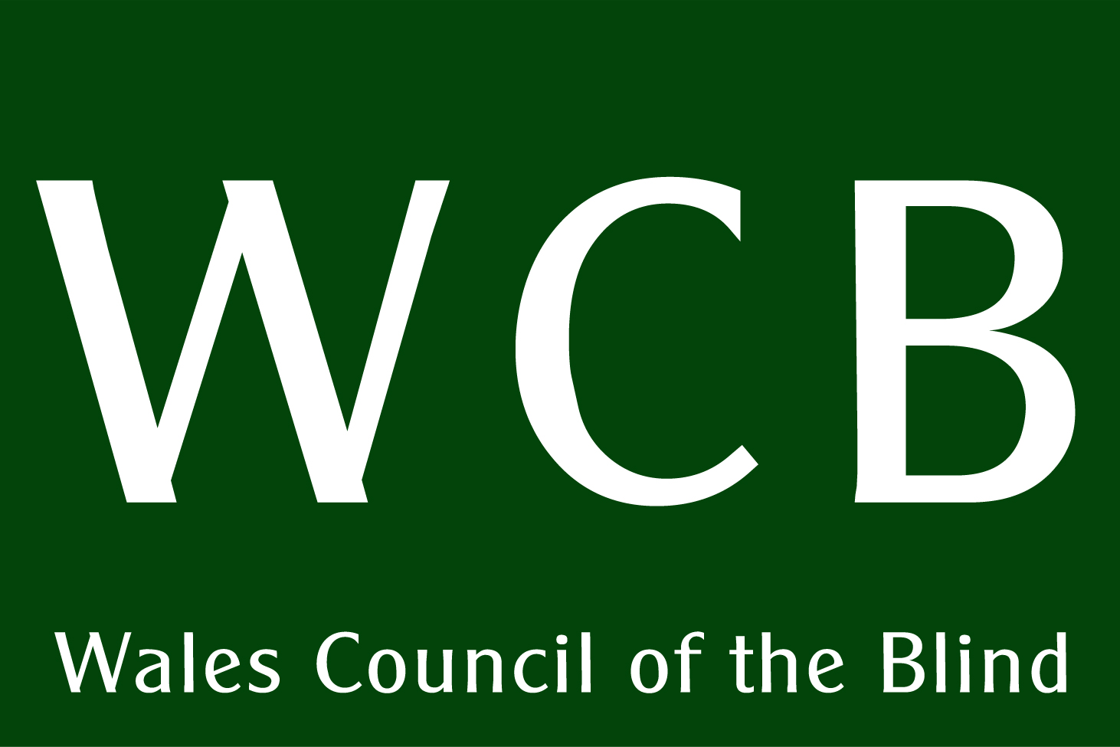 | 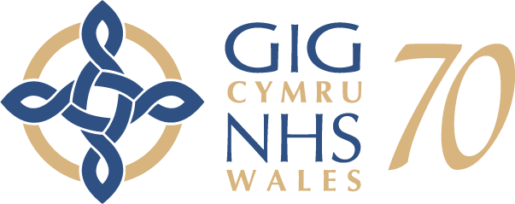 | 

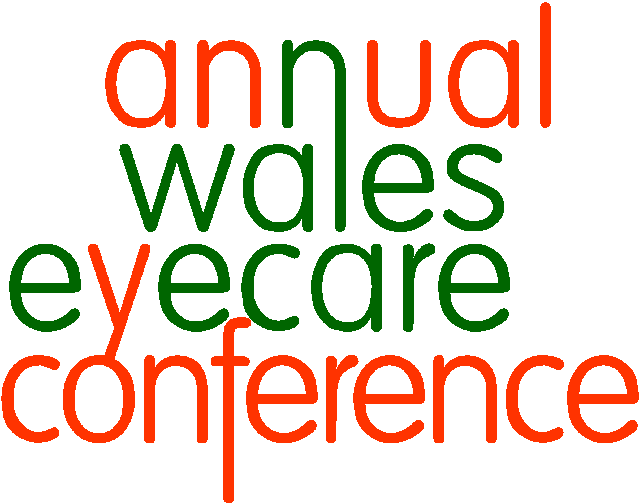2018 Celebrating 70 years of the NHS in Wales

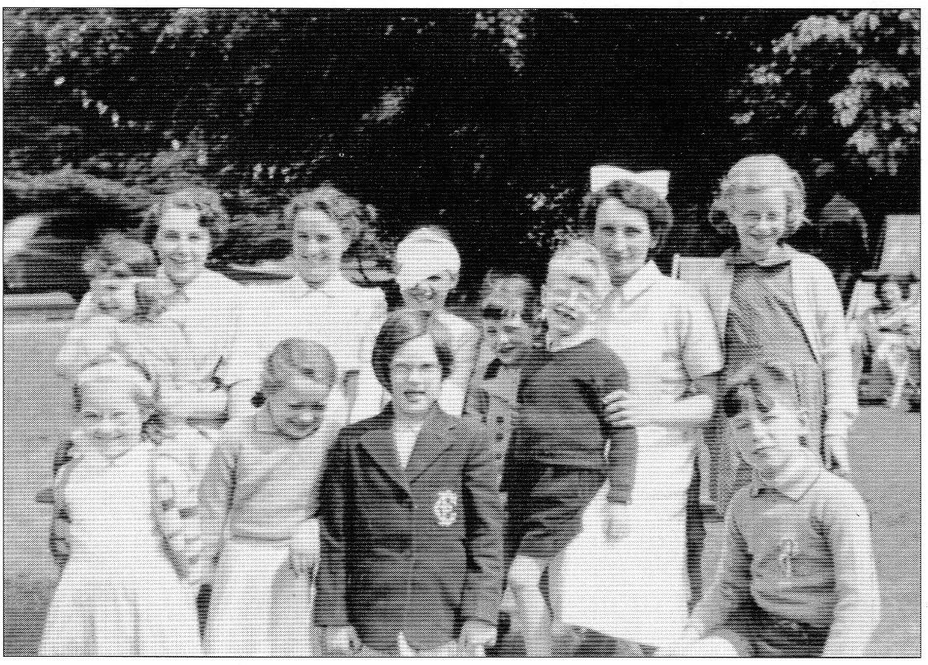
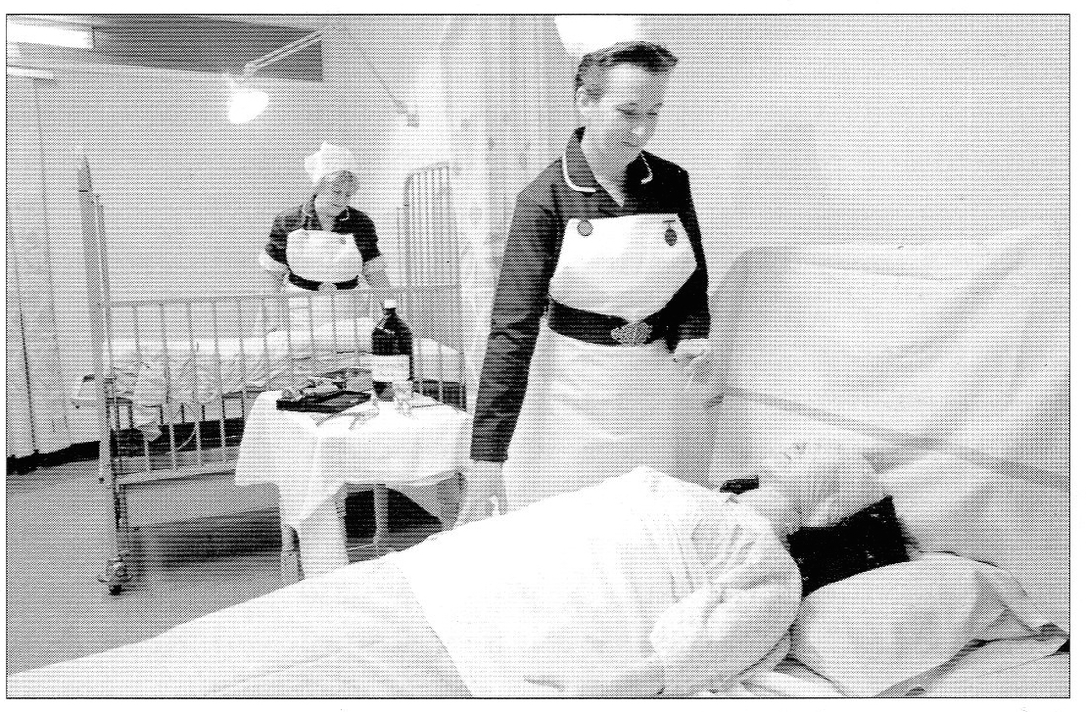

#eyecareconference

Conference website:
http://www.wcb-ccd.org.uk/conference/conference.php
Celebrating 70 years of the NHS in Wales
Programme of the day.

Chair: Gwyn Williams, Consultant Ophthalmologist
Abertawe Bro Morgannwg University Health Board

09:15 Coffee and registration

10:00 Welcome and Introductions
Chair of the day, Gwyn Williams

10:05 National Eye Health Week key message
Owen Williams, Director, Wales Council of the Blind

The refresh of the Wales Vision Strategy
Ansley Workman, Director, RNIB Cymru

10:15 Celebrating 70 years of the NHS
WCB Storm / UCAN Productions

10:30 70 years of the NHS
Frank Atherton, Chief Medical Officer

10.50 Wales Eye Care Service
David O’Sullivan, Chief Optometric Advisor (COA) for Wales and Professor Barbara Ryan (former COA)

11:15 COFFEE BREAK

11:45 Children’s School Vision Pathway Project
Heather Payne, Senior Medical Officer for Maternal and Child Health and Rebecca Bartlett, Clinical Low Vision Lead

12:00 Update on Rehabilitation and Habilitation services in Wales
Ian Moran, Chair of the Wales Rehabilitation Officers Forum,
Jonathan Mudd, Head of Mobility Services, Guide Dogs Cymru.

12:20 Falls Prevention
Sandy Davies, Rehabilitation Officer for the Vision Impaired (ROVI), Bridgend and Kelly Williams, Bridgend Care and Repair
12:35 Ophthalmology State of the nation
Mike Austin, Consultant Ophthalmologist, Abertawe Bro Morgannwg University Health Board

12:50 Patient perspective: Outcome Focus Measures
Gareth Davies, Health Stakeholder Engagement (UK), RNIB

13:00 LUNCH

14:00 Dementia and sight loss
Sue Phelps, Director, Alzheimer's Society Cymru

14:15 Updates from Local Health Boards
1 key success and 1 key challenge
Fiona Jenkins, Chair, Wales Eye Care Steering Board

14:30 Cabinet Secretary Address
Vaughan Gething AM, Cabinet Secretary for Health and Social Services

14:45 What will the future hold?
WCB Storm / UCAN Productions

14:55 Stroke and sight loss
Matt O’Grady, Information, Policy and Campaigns Officer, Stroke Association in Wales

15:10 Together for Health: Eye Health Delivery Plan
Fiona Jenkins, Chair, Wales Eye Care Steering Board

15:25 Update on the Accessible Information Standards for People with Sensory Loss
Marcia Morgan, Programme Manager, Centre for Equality and Human Rights (CEHR), Public Health Wales (PHW)

15:40 Closing remarks
Chair of the day, Gwyn Williams

15:50 CLOSE

Exhibition stands:
- National Eye Health Week
- Public Health Wales
- Eye Health Examination Wales/Wales Eye Care Service
- Low Vision Service Wales
- Diabetic Eye Screening Wales
- Wales Vision Forum
- Welsh Rehabilitation Officers Forum
- MEGAFOCUS

The photographs on the cover show a mock-up of an eye ward and children with eye problems with nurses in the 1950s, both from a booklet published by Glan Clwyd Hospital Trust.

A brief history of Ophthalmology in the NHS.

To celebrate 70 years of the NHS, this article has been compiled from a number of pieces by Carl Pierce, who was Clinical Nurse Manager in Ophthalmology in North Wales from 1961 to 2001. He gives a fascinating insight into the changes that has witnessed in ophthalmology over the decades.

The Second World War had only recently ended and there was still austerity. When the NHS was introduced in 1948 the patients' reaction was “Gosh! Is the service free?” The public was grateful for the treatment and were willing to queue and wait. In the wards, patients brought their own eggs for breakfast and it was sister's job to boil or fry as required.

Cataract surgery was only carried out if you were nearly blind: this entailed bed fast for 10 days with both eyes covered; fed and watered; blanket bathed. Confusion was common including deep vein thrombosis and pulmonary embolism. Extracapsular surgery was carried out leaving lens matter in the eye. This caused severe inflammatory reaction and iris prolapse was common, needing more surgery and more bed rest. Patients had thick glasses that reduced their field of vision and made walking hazardous. Patients were known to fall and break their hips.

Children with squint had anaesthesia with ether, resulting in vomiting in many cases. Both eyes were padded from 5-10 days and no visiting was permitted. Inflammation of the eyelids (blepharitis) and corneal ulcers were common.

Patients with retinal detachments were often kept in bed for up to three weeks and diathermy – an electrically generated heat treatment - was the choice for surgery. Leeches were in common use and teeth were removed for iritis, an inflammation of the iris. A special dental day for tooth extraction was held at the Hospital. A big breakthrough was Diamox to help reduce intra-ocular pressure. Before this, surgery often had to be carried out on hard, red eyes. Atropine and Hyoscine poisoning from eye drops often occurred.

In 1954 the Eye Unit in HM Stanley opened and Mr. Edward Lyons was appointed as Eye Surgeon to North Wales. However, there were no beds available and surgical cases were referred to Liverpool.

The ability to perform surgery at the Hospital did not arise until 1961 when the Eye Theatre was opened. The Eye Unit at that time consisted of 16 beds and 4 children's cots. Cataract surgery was only carried out if you were nearly blind. Initially, instruments were sterilised in disinfectant fluid until a hot-air oven was acquired.

The décor of the unit included a coal fire and dark brown tiles. Drums with dressings were packed on the ward and sterilised by the porters. No training! Eye pads were cut from gamgee tissue by the nurses, resulting in blistered fingers. Sheets were changed once a week with the top sheet put on the bottom so you only change one sheet per week. Blankets were wool and were dry-cleaned once a year, the whole ward being closed for up to a week. Between patients, beds were washed down with carbolic. Nurses washed their hands with washing soap. Only Consultants were allowed to use toilet soap. Anything white was starched, and there was only one glass thermometer per ward. If you broke a thermometer you reported to the matron. Syringes and needles were washed and used again and again. Only when needles had hooks on were they thrown away!

Waiting lists were long with operating lists held twice weekly – there was no microscope or prepared sutures (stitches). The Unit had one consultant and shared a Junior Doctor with the Ear, Nose and Throat Clinic. The one Night Nurse on duty was required to wash all patients. Only one set of drops was available to be shared for 'clean patients' and one set for 'dirty patients'.

The 1960s saw major changes in Cataract surgery: the whole lens could now be removed with a special ice probe and silk sutures were introduced. Surgery was safer and eyes healed with fewer complications. Artificial lenses were beginning to be inserted into the eye to replace the lens that had been removed, resulting in dramatic improvements in vision and removing the need for thick glasses. The Eye Unit had the first Operating Microscope in Wales, improving surgery considerably. A hand-held Fundus camera was purchased – another first – producing excellent photographs of the inside of the eye. Also, disposable syringes and needles were introduced. An Orthoptic Department was also started with a single-handed orthoptist in a clinical room in the Eye Outpatients Department.
By the 1970s a much-improved Fundus camera allowed introduction of flourescence angiopathy. Treatment of diabetic eye changes could now be carried out using a Xenon arc laser – before this you simply became blind. Cataract surgery now had the advantage of finer sutures produced commercially that were no longer threaded by hand. The department appointed a second Consultant in 1974.

In the 1980s there was a major upgrade of the Unit following a move of the Ear, Nose and Throat (ENT) Department to Ysbyty Glan Clwyd. A new clinic area was created and the ward and theatre upgraded. The purchase of additional Argon & Krypton lasers widened treatment options for some patients. A development in surgical technique in cataract surgery resulted in safer operations and improved outcome where the back membrane could be preserved where a new lens could be fitted. The first Ophthalmic course commenced in Wales, and has remained the only post-graduate study course for nurses in the Principality, and the Bristol Eye Bank was established.

Further dramatic changes were seen in the 1990s, brought about by the Hospital gaining Trust status. The Ophthalmic Directorate was set up, and became fully responsible for quality assurance, meeting contracts and finance targets. Computers were introduced into the Directorate and a third Consultant employed. Cataract surgery employs the phacoemulsification technique with the use of improved lens implants. By now Day Surgery was the order of the day with over 80% of surgery carried out as day care. Beds were reduced from 24 to 8 as the Day Care unit adopted preferred reclining chairs. The Nurse Practitioner role developed formally to provide a casualty service and shared care in glaucoma clinics.

The Directorate moved from strength to strength because of staff who have a 'can do' culture and a 'win-win' outlook.

The new millennium saw further expansion of digital services enabling new treatment options for a variety of patients including those with macular degeneration. This service expanded both locally and nationally with the advent of NICE (National Institute of Clinical Excellence) guidance and available pharmaceutical products producing a significant increase in the volume of patients able to access treatment for their condition. The Eye Clinic Liaison Officer (ECLO) role was also introduced to the Unit in conjunction with Macular services to provide a supporting role for those with low vision needs. In addition this was the decade that patient support groups were developed within Ophthalmology, with monthly meetings scheduled for those affected by Glaucoma and a Low Vision support group.

In 2011 the Eye Unit comprised a Day Care Unit, two operating theatres, out-patient department, casualty triage unit, an Orthoptic Department, and peripheral clinics on five sites. Approximately 5,000 surgical cases were performed annually. The Ophthalmic Outpatient Department saw over 40,000 patients annually in addition to casualty attendees, and provided formal ophthalmic nurse training at post-graduate degree level and advanced skills utilisation for ophthalmic nurse practitioners. The Unit strived continuously to develop and provide quality patient care, and continued to do so following the relocation of the service from HM Stanley to Abergele Hospital in 2012.
Chair of the Day.

Gwyn Samuel Williams, Consultant Ophthalmologist.

Gwyn Samuel Williams is a consultant ophthalmologist with an interest in medical retina based at Singleton Hospital, Swansea. He trained in ophthalmology on the Wales rotation and completed his fellowship at Moorfields Eye Hospital, London. He is also an Honorary Senior Lecturer at the University of Swansea.

He has authored a book about the practical management of inflammatory eye disease, written chapters in medical textbooks and also published a novel. Gwyn is a Section Editor for Eye News magazine for which he writes a bi-monthly column. His interests include hiking, reading and writing and he has a special interest in medical education. He lives in Swansea.

National Eye Health Week key message

Owen Williams, Director, Wales Council of the Blind.

Owen was appointed as the Director of Wales Council of the Blind (WCB) in 2012 and has over 20 years’ experience of working within the sight loss sector in Wales.

He sits on a number of all Wales groups including Welsh Government’s Eye Health Care Steering Group and is the Chair of the Low Vision Service Wales Advisory Group. He has a background in access technology and providing specialist assessments and advice. Owen has also worked on a number of projects within health and social care.

Owen is partially sighted and this enables him to bring a unique service-user perspective.

The refresh of the Wales Vision Strategy

Ansley Workman, Director, RNIB Cymru.

Ansley has worked with RNIB Cymru for 8 years, most recently in the role of Network Manager. Ansley has over 30 years’ experience in the support and housing sectors in Wales and was previously the Chief Executive of a Housing Association for people with learning disabilities and complex needs.

Celebrating 70 Years of the NHS

Megan John

Megan John is 26 years old living in Cardiff. Megan was born with congenital Cataracts, Aniridia, Nystagmus and Photophobia. She is a performer who loves acting and has an interest in directing. Megan achieved a BA (Hons) in Drama and Theatre studies at Aberystwyth University. She is a founder member of UCAN Productions. Megan runs drama and Visual Awareness training workshops with UCAN as well as running the Storm WCB project alongside Mared, which is a partnership project with WCB. UCAN is a creative arts Co-operative run by and for blind and partially sighted young people who work in developing vocal and physical confidence through the arts. Over the last 13 years Megan has performed in all of UCAN’s major core group productions.

Mared Jarman

Mared is 23 years old and lives in Cardiff. She was diagnosed at 10 years of age with Stargart’s. She is an actor singer who works both as a backing vocalist and solo artist. She is a founding member of UCAN Productions. Megan runs drama and Visual Awareness training workshops with UCAN as well as running the Storm WCB project alongside Mared. Over the last 10 years Mared has performed in all of UCAN’s major core group productions. As well as being a long time member Mared is now a part of the team of trainers who deliver workshops across the country.

WCB Storm

Wales Council of the Blind, in partnership with UCAN, is working specifically with young adults in a project led by Megan and Mared. They aim to give all young adults across Wales the opportunity to have their voices and opinions heard. Through setting up regional groups they hope to get everyone involved in helping to create better signposting for local services, shaping and advising on the services that are needed and ensuring that every individual has access to the same services. They will also be utilising social media to share their thoughts and open discussions, create an online community and to promote services.
70 Years of the NHS

Frank Atherton, Chief Medical Officer, Welsh Government

Frank took up post of Chief Medical Officer, Medical Director NHS Wales in August 2016.

Frank graduated in medicine from Leeds University and worked in hospital and primary care posts around the North of England for a number of years before undertaking voluntary work as a District Medical Officer in Malawi. On his return to the UK he completed specialist training in Public Health Medicine in the Yorkshire Region and then worked on international health and development issues for WHO and the UK Department for International Development in various locations including the Former Yugoslavia, Tanzania, and Bangladesh. From 2002 to 2012 Frank worked as a Director of Public Health in Lancashire and from 2008 to 2012 he also served as President of the UK Association of Directors of Public Health (ADPH). In 2012 Frank moved to Canada to take up a post as the Deputy Chief Medical Officer of Health in the Department of Health and Wellness, Nova Scotia.

Wales Eye Care Service

David O'Sullivan, Chief Optometric Advisor for Welsh Government

David qualified as an optometrist with a First Class Honours degree from Glasgow Caledonian University in 1996 and completed training in Leeds general infirmary. Following a short spell in private practice he relocated to Wales in 1998 where he became a practice owner. Over the past 18 years expanded from one practice to a small group of practices within Cardiff and the Vale of Glamorgan.

He became accredited to provide Welsh Eye Care Initiative services (now Eye Health Examination Wales) and low vision services in the first cohort of practitioners for both services and has subsequently undertaken further postgraduate qualifications in glaucoma management.

In 2001 he became the Optometric Development Officer for Carmarthenshire Local Health group, which has subsequently developed into Hywel Dda University Health Board. This was the first position of its kind in Wales and provided a link between primary and secondary care providing the platform for developing services in the community.

In 2015 he became the Optometric Adviser for Cardiff and the Vale of Glamorgan University Health Board and in July 2017 became the Chief Optometric Adviser for Wales.

Professor Barbara Ryan.

Professor Barbara Ryan spent her early optometric career in the Hospital Eye Service in Oxford, Nigeria and Birmingham and in the voluntary sector working for the local charity Birmingham Focus and the national charity, the Royal National Institute for the Blind.

In 2003 she moved to Wales. Based at Cardiff University, she was the founding Clinical Lead for the Low Vision Service Wales and then in 2009 was one of the founding Directors of Wales Optometry Postgraduate Education Centre (WOPEC) in the School of Optometry and Vision Sciences, Cardiff University.
From 2012 to 2016 Barbara was seconded to Welsh Government as Chief Optometric Adviser.

Barbara practices one day a week in a community practice in Aneurin Bevan University Health Board and is Director of Postgraduate Taught Programmes in the School of Optometry and Vision Sciences, Cardiff University.

Children’s School Vision Pathway Project

Dr. Heather Payne, Welsh Government Senior Medical Officer for Maternal and Child Health.

Heather offers professional advice on: paediatrics and child health; health aspects of safeguarding children and adults; health aspects of fostering and adoption; early years and child development; service quality, safety and outcome measures for children and maternity; inter-professional working and learning.

Rebecca Bartlett, Clinical Low Vision Lead.

Rebecca Bartlett is Clinical Lead for Low Vision Services Wales and for the School Pupil Eye Care Service project. She is also module lead for Cardiff University Postgraduate Optometry Low Vision Theory and Practical modules. She has a special interest in children’s vision and eye care for children and young people with additional learning needs.

Rebecca graduated from Cardiff University in 2004, achieved her professional qualifying exams and continues to practice across a wide breadth of optometric practice including; special schools, hospital optometric service and community practice. She recently achieved her postgraduate certificate in Clinical optometry.

Update on Rehabilitation and Habilitation services in Wales

Ian Moran, Chair of Welsh Rehabilitation Officers Forum.

Ian has worked in the sight loss sector providing frontline services to blind and partially sighted people for over 20 years.

He started work as a volunteer for Liverpool Voluntary Society for the Blind and went on to work for RNIB and supported VI students to access further education in Colleges and Universities in Liverpool.

Ian moved to London and worked for 2 years in a Secondary School managing a resource centre providing support to enable VI children to access the mainstream curriculum.

Ian moved to Wales with his family in 2006 and studied at Birmingham City University to become a qualified Rehabilitation Officer for people with a Vision Impairment (ROVI). Since qualifying he has worked for Rhondda Cynon Taff's Sensory Services Team for 9 years.

Ian is the current Chair of the Welsh Rehabilitation Officers Forum (WROF), which is the professional body that represents Rehabilitation Officers in Wales.

Jonathan Mudd, Head of Guide Dogs Cymru.

Jonathan’s background is in rehabilitation and childcare; he has been working with blind and partially sighted people for 35 years. He is passionate and proud that his organisation supports people throughout their lives with examples of current work including the support of a 3 year old learning long cane skills and a new Guide Dog partnership with a 87 year old. His priority is to work with others to ensure that there are more appropriate and consistent services across Wales that allow people of all ages to gain independence and reach their full potential
Falls Prevention

Sandy Davies, Rehabilitation Officer for the Visually Impaired

Sandy has had a very personal experience of sight loss. During this time she volunteered with Wales Council of the Blind delivering awareness training across Wales. Sandy then formally trained as a Rehabilitation Officer (ROVI) in Birmingham and qualified in 2009. Since then she went on to complete the BSc in Rehabilitation Studies in Visual Impairment. Sandy volunteered for Cardiff Institute for the Blind. She initially worked in London as a ROVI and then returned to Wales working in Neath Port Talbot and currently in Bridgend Sensory Services. Between these posts she has worked in Care & Repair as a Managing Better Caseworker and was part of the service when it was originally set up. She still works pro-actively with Bridgend Care & Repair, Care & Repair Cymru and the Managing Better Service across Wales. Sandy sits on the Welsh Rehabilitation Officers Forum (WROF) and was elected vice chair in May this year. She works in partnership with other professionals in Health, Primary and Secondary Care and Third Sector Organisations.

Sandy is passionate about sight loss and is constantly working to better co-ordinate services and other professionals to the benefit of vision loss. She is a keen sportswoman.

Kelly Williams, Managing Better Caseworker, Bridgend County Care & Repair

Kelly developed knowledge and understanding of sight loss and the impact it has on individuals when she started her role with RNIB Cymru in 2011. During the 5 years at RNIB Kelly represented people with sensory loss at Social Security Tribunals across Wales.

Kelly now fills the role as a Managing Better Caseworker with Bridgend County Care & Repair and works proactively with Health and Social Care to ensure people with sensory loss, stroke survivors or people living with dementia live in safe, warm, healthy home environments in order to reduce falls risk before they reach crisis point and enter the statutory system of hospitals, GPs or residential care. Kelly has gained a Trusted Assessor Qualification with Bridgend County Care & Repair allowing her to prescribe minor aids and adaptations.

Through Open University and University of Wales Trinity St David (UWTSD), Kelly has been able to gain qualifications in Health Sciences, Advocacy, Health and Social Care, and is currently working towards a BA Hons Leadership and Management. In 2016 Kelly was presented with an Outstanding Student of the Year award by UWTSD jointly with the Institute of Leadership and Management (ILM).

Ophthalmology State of the nation

Michael Austin, Consultant Ophthalmologist

Mike qualified in 1983 and after house jobs in Cardiff he moved north for ophthalmic training at St. Paul’s Eye Hospital Liverpool, University Hospital Aberdeen and Queen’s Medical Centre, Nottingham.

As a consultant in Swansea from 1995 Mike has continued to develop his interest in the early detection and management of glaucoma in particular with the then novel concept of a glaucoma assessment clinic led by clinicians in professions allied to medicine backed up by virtual clinic consultant review. A number of audits, research projects, presentations and publications have helped to confirm the place of multidisciplinary team working.

Mike has been active in medical education in Swansea University and is an honorary senior clinical lecturer for the College of Medicine. In 2012 he took on the role of Royal College of Ophthalmologists regional advisor for Wales and this has led to much collaborative work with allied professions and Welsh Government. He is currently chair of the Wales Ophthalmic Planned Care Board.
Patient perspective: Outcome Focus Measures

Gareth Davies, RNIB

Gareth’s role within the RNIB is that of Health Sector Stakeholder Lead (UK). This role involves working with the NHS in Wales, Englsnd, Scotland and Northern Irelend and their respective Governments to improve clinical and social outcomes for patients.

Gareth is a member of the Welsh Ophthalmic Planned Care Board and holds the role of ‘Patient Representative’ ensuring the voices of Welsh patients is heard.

Gareth was registered blind in 2014 due to Retina Pigmentosa and is also a Guide Dog Owner, he hopes to represent England in the Blind Rugby World Cup next year in Japan (Please note Wales do not have a team hence playing for England!)

Dementia and sight loss

Sue Phelps MBE, Country Director, Wales, Alzheimer’s Society.

Sue Phelps has worked in the voluntary sector in England and Wales for over 30 years.

Sue began work with the Alzheimer’s Society twenty-two years ago as an administrator following the death of her grandfather who had Alzheimer’s disease and has held a number of service development and management posts within the organisation before becoming Country Director in September 2017.

The Alzheimer’s Society has grown substantially over its thirty-eight years and is now one of the fastest growing charities in the UK. The organisation’s vision is of a world without dementia and to create a society where people with dementia feel included, respected and able to lead the lives they want without fear or prejudice. The focus of the Society’s five year strategy, New Deal on Dementia 2017-2022, is to develop and deliver high quality information and support service for people living with dementia; to campaign and champion the rights of everyone with dementia and those who care for them and to galvanise investment for research into the causes, prevention, treatment and care of people with dementia and to raise much needed funds.

Public awareness of dementia has increased dramatically over recent years and it is now high on the political agenda. The staff and volunteers working for Alzheimer’s Society continue to be a passionate group of individuals committed to raising awareness, reducing stigma and improving the lives of people living with dementia and Sue is proud to lead and be a part of that workforce. She was delighted to be awarded an MBE in the Queen’s Birthday Honours in 2017 for services to dementia in Wales.

Updates from Local Health Boards - 1 key success and 1 key challenge

Regional Multi-Disciplinary Eye Care Health Groups

Eye Care Health Groups have been set up in every health board. Membership includes clinicians from primary and secondary care, managers and the third sector. All health boards have also developed local eye care plans which outline the eye care needs of their local population and how they plan to meet them.

Fiona Jenkins, Chair of the Wales Eye Care Steering Group, will present the story around Wales and report 1 key success and 1 key challenge from each Local Health Board.

Cabinet Secretary Address

Vaughan Gething AM, Cabinet Secretary for Health and Social Services

Vaughan Gething was born in Zambia and brought up in Dorset. He was educated at Aberystwyth and Cardiff Universities, and is married to Michelle. Vaughan is a largely retired cricketer and a fan of both rugby and football.

Vaughan was a solicitor and former partner at Thompsons. He is a member of the GMB, UNISON and Unite unions, and was the youngest ever President of the TUC in Wales. He has previously served as a county councillor and school governor. He has also been a community service volunteer – supporting and caring for a student with cerebral palsy, and is former president of NUS Wales.

Between 1999 and 2001, Vaughan worked as a researcher to former AMs Val Feld and Lorraine Barrett. Between 2001 and 2003, Vaughan was the chair of Right to Vote – a cross-party project to encourage greater participation from black minority ethnic communities in Welsh public life.

Vaughan is a member of the Co-operative Party.

In June 2013 Vaughan Gething was appointed Deputy Minister for Tackling Poverty. In September 2014, Vaughan was appointed Deputy Minister for Health. In May 2016 he was appointed Cabinet Secretary for Health, Well-being and Sport.

Stroke and sight loss

Matt O’Grady, Policy, Information and Campaigns Officer, Wales for the Stroke Association.

Matt has previously worked as an Equality and Diversity Officer for a small housing charity, providing training and support to the housing sector in Wales on issues around equality and diversity. He has also previously been the Senior Policy and Campaigns Officer (Wales) for Scope as well as working for an AM in the National Assembly.

Originally from Somerset, Matt graduated in Politics from Swansea University.

He works closely with the Cross Party Group on Stroke in the National Assembly to ensure stroke is high on the political agenda in Wales. He also works with Welsh Government, the NHS and local authorities to highlight the need for the best possible stroke service in Wales.

Matt also ensures the voices of stroke survivors are heard at the highest level by politicians and organisations in Wales.

Together for Health: Eye Health Delivery Plan

Dr Fiona Jenkins, Executive Director for Therapies Health Science, Cardiff and Vale University Health Board.

Fiona is a Chartered physiotherapist with significant clinical, managerial and leadership experience. She joined Cardiff and Vale UHB in 2010.

Fiona has a PhD related to NHS Management and completed the INSEAD NHS / Leadership Centre Clinical Strategists’ Programme. She also holds an MA in Management, and is a Fellow of the Chartered Society of Physiotherapy.

Her Executive portfolio includes:
National lead roles: Chair Wales Eye Care steering group; Chair Wales Respiratory Health Delivery Plan; Chair Wales Stroke Improvement group.
Cardiff and Vale UHB lead roles: Executive Lead Information Technology, Stroke, Eye Care, End of Life, Falls, Learning Disabilities, Armed Forces and Veterans, Medical Equipment, Decontamination and Nutrition. She is also particularly interested in health and social care integration and ensuring the delivery of care in community settings. In addition Fiona is accountable for leading the 1800 Therapists and Healthcare Scientists in the organisation.

Fiona lectures both nationally and internationally, and is also co-editor of a series of “The Allied Health Professions Essential Guides.”

Update on the Accessible Information Standard for People with Sensory Loss

Marcia Morgan, Programme Manager, Centre for Equality and Human Rights (CEHR), Public Health Wales (PHW);

Marcia has worked for Welsh Government since 2000 across various departments. Marcia joined the Health and Social Services Group as Senior Equality Manager in 2011 and has been involved in various areas of work including LGBT+ (Lesbian, Gay, Bi-sexual and Trans), BME (Black, Minority and Ethnic) and sensory loss. She worked collaboratively with the CEHR, third sector organisations and service users to help produce the All Wales Standards for Accessible Communication and Information for People with Sensory Loss (the All Wales Standards).

Following on from the All Wales Standards, Marcia has continued to work with the CEHR and third sector partners as Project Manager to create an Accessible Information Standard. This is a national, Welsh Government led project to capture, record, transfer and flag the communication and information needs of those with sensory loss when accessing healthcare.

Since January 2018, Marcia has been on secondment to the CEHR as Programme Manager to engage both with the community and health professionals and raise awareness of the Accessible Information Standard.

EXHIBITORS

Wales Vision Forum
The purpose of the Forum is for Third Sector organisations representing people with sight loss to share, discuss and outline work programmes and priorities to enhance joint working and reduce duplication to maximise their collective reach and impact. The Forum is a platform for sharing information, sharing good practice and expertise, consulting and identifying opportunities to support service and campaign planning. The Forum meets a minimum of three times a year. Task and finish groups can be established for specific areas of work.

Membership is open to local, regional and national constituted organisations working with blind and partially sighted people in Wales. Other organisations may be invited to meetings or part of meetings as agreed by members.

The Forum has a representative on the Wales Eye Health Care Steering Board and on each of its sub groups and task and finish groups, as well as each of the Regional Multi-Disciplinary Eye Care Health Groups.

Wales Council of the Blind chairs - and provides secretariat for - the Forum. For further information contact Owen Williams on 029 2047 3954 or by email at owen@wcb-ccd.org.uk

Optometry Wales

Optometry Wales is the professional, umbrella organisation for all primary care optometrists, dispensing opticians and optometric practices across Wales.

The Welsh Rehabilitation Officers Forum

Our Forum was established at the end of 2007 in an attempt to secure a voice for consultation for the Rehabilitation Officers in Wales in the ever-changing visual impairment world whether political, professional or service based. Our membership is open to all qualified Rehabilitation Officers, Assistant Rehabilitation Officers, Student Rehabilitation Officers and Mobility Instructors.

Since the launch of our Forum we have made ourselves available for consultation to Welsh Government, employers, local authorities and also the Third Sector organisations. This has resulted in our direct involvement with the Visual Impairment Service Benchmarking process, the Sensory Impairment National Occupational Standards and the development of our Continuous Professional Development scheme.

Our focus has been to bring about mandatory registration of our profession. This is to ensure that all our members are working to a high standard, are accountable for their work and have ongoing training to develop their skills.

The issue of mandatory registration of the ROVIs in Wales remains high on the agenda for WROF. The code of ethics/professional conduct, the formal job description and the continuous development programme have all been aimed at meeting the registration requirements needed by the Professional Standards Authority, who are the regulators for both Social Care Wales and the Health Care Professional Council. This we hope will bring our profession in line with Social Workers, physiotherapists and Occupational Therapists.

Over the past 12 months we have been working with our overarching professional body, The Rehabilitation Workers Professional Network (RWPN) to ensure there is a UK wide standard and to implement the infrastructure to record and monitor our CPD. A voluntary register will open in January 2019 and we feel that this is a huge step forward for our profession.

We believe that all people with a vision impairment or sight loss, must have timely access to Rehabilitation intervention, no matter where they live in Wales.
Diabetic Eye Screening Wales (DESW)

DESW (formerly DRSSW) is designed to detect sight-threatening retinopathy at an early stage before visual loss occurs. The service was commissioned in July 2002 by Welsh Government as part of the Welsh Eye Care Initiative (WECI) risk reduction programme and the Diabetes National Service Framework (NSF). Every eligible diabetic person registered with a GP in Wales is invited for retinal screening on an annual basis.

The service is community-based, delivering from over 150 sites across Wales. DESW screens over 125,000 patients each year, with a population growing at about 1,000 patients each month. Each year we refer over 5,000 patients identified as being at risk of sight loss to specialist eye services.

A recent publication (Thomas et al. BMJ 2017) shows that registered blindness in Wales due to diabetes has fallen by half since the retinal screening programme was established. This is really strong evidence for the effectiveness of the care pathway in NHS Wales and an encouragement to people living with diabetes to maintain their diabetic control and attend their DESW screening appointment.

Low Vision Service Wales (LVSW)

What is it?
Wales is unique in its provision of a national primary care rehabilitation service for adults and children with impaired vision. This community based service has been in existence since 2004 and provides a wide range of specialist visual aids and equipment such as magnifiers and lamps free of charge. The service is hosted by Hywel Dda Health Board on behalf of all health boards in Wales and is provided in many optometry practices (opticians) on high streets throughout the country.

Who can use the service?
Anyone struggling to read newspaper print with their strongest lenses or glasses is likely to be eligible for referral. A recent eyesight test that shows a visual acuity (both eyes best corrected) of N6 or worse or 6/12 or worse will confirm this. The service provides for both adults and children with impaired vision, however the majority of the LVSW patients are of advanced age.

What does the service do?
A specially accredited Low Vision Practitioner will test a patient’s vision, discuss their eye condition/s with them and provide advice that might help with any activities they may currently find difficult. The practitioner can also direct clients to further help from local Social Services, their GP, pharmacist, voluntary support groups and other resources in their area.
By helping people find the right magnifiers and lighting to suit their particular needs, people with impaired vision can find it becomes easier to do many day-to-day activities such as reading, seeing the controls on a cooker, managing any medication and maintaining independence.

How to access the service
This enhanced NHS service is completely free and referrals are accepted from a wide range of professionals. It is also easy to self-refer simply by contacting a local Low Vision Practitioner, a list of which can be found either on www.eyecarewales.nhs.uk or by contacting the service direct (see contact details below).

Story so far…
To date nearly 46,000 people have accessed the service, which currently has 195 accredited Low Vision Practitioners working out of approximately 202 optometry practices (opticians) in Wales. This accounts for over 201,000 individual low vision aids prescribed so far free to patients who require them. (Figures correct July 2018).

Contact details
You can access more information about the Low Vision Service Wales and find contact details for optometry practices (opticians) that provide the service in your area at www.eyecare.wales.nhs.uk

For other enquiries call 01267 248793 or email low.vision@wales.nhs.uk

MEGAFOCUS (Minority Ethnic Groups Association for Ophthalmic Care Uptake and Service) Advisory Group

Ethnicity influences the risk of sight loss. People of South Asian and Black origins have indicated 2-6 times more chance of developing eye conditions leading to sight loss compared to the white population. Although they are high-risk groups, a low level of engagement with eye care has been noted amongst these communities. With the growing ethnicity population in Wales there is a growing concern and therefore MEGAFOCUS was set up to tackle the problem and prevent unnecessary sight loss amongst these communities. MEGAFOCUS has brought together eyecare professionals, third sector organisations and policy-makers to improve the relationship between ethnic minority communities and eyecare in Wales and thereby prevent unnecessary sight loss.

Eye Health Examination Wales

The Eye Health Examination Wales (EHEW) is part of the Wales Eye Care Service (WECS). WECS is inclusive of the EHEW, Low Vision Service Wales (LVSW) and the Diabetic Eye Screening Wales (DESW) service. It is funded by the Welsh Government and Health Boards and managed by the Health Boards in Wales.

The Eye Health Examination Wales is an extended eye care service which is free at the point of access for patients and demonstrates the principles of prudent health care enabling patients to access eye care services closer to their home.

The service has been in operation in different formats in Wales since 2003 and has been partly replicated across England and Northern Ireland due to its success and the impact it has had for patients and professionals here in Wales. Optometrists who provide the service undergo ongoing training and re-accreditation every 3 years. The service is subject to audit and evaluation.

Patients are able to access the EHEW service in a primary care optometry practice if they have an eye problem they feel needs urgent investigation, rather than attending a GP practice, Emergency Department (A & E) or an Eye Department in a hospital. This reduces the demands on GPs and the Emergency Departments.

The service also enables patients who are at greatest risk of developing a serious eye condition or those who would be particularly disadvantaged if they lost their eyesight, to have an annual check at an optometry (optician’s) practice. This is a preventative measure as many eye diseases can be undetected until the later stages when significant damage is already done to the vision. Early detection saves sight loss in those pre-disposed to developing eye conditions such as glaucoma.

The EHEW service has provision to monitor patients discharged from hospitals following uncomplicated cataract extraction and those with Ocular Hypertension (OHT) or who are glaucoma suspects. This reduces the burden on the Hospital Eye Service.
The service is effective in reducing the number of patients being referred to the hospital eye care service, has a very high patient satisfaction rate and means patients can be seen closer to home.

As a patient if you live in Wales or have a GP in Wales you can go along to an EHEW registered optometrist (optician) practice and ask to have an EHEW examination if:

- You have an eye problem you think needs urgent attention
- You have sight in one eye only
- You’re registered as sight impaired
- You have a hearing impairment and are profoundly deaf
- You suffer from retinitis pigmentosa.
- You are of Black or Asian ethnicity
- Your GP has referred you (the optometrist will need to confirm if you can have an EHEW examination)

Over 90% of optometrist (optician) practices offer the EHEW service so it is likely that your local practice provides the service. You can check which optometrist practices offer the service and find out more information by visiting eyecare.wales.nhs.uk.

It is a good idea to telephone ahead to book your appointment. The optometrist (optician) will carefully examine your eyes to see if anything is wrong. The tests and equipment they use will depend on what you tell them and what they find. An eye health examination is more in-depth than and different to a routine vision test, so it may take longer.

Wales Eye Care Services: www.eyecare.wales.nhs.uk
for more information about the Low Vision Service Wales, Diabetic Eye Screening Wales, Eye Health Examination Wales and links to third sector organisations.

Public Health Wales - Smoking, eye health and quitting

Smoking remains the single largest cause of preventable ill health in Wales with 19% of Welsh adults reporting that they smoke (2015). Tobacco smoking is the single most controllable risk factor that contributes to the development of age-related macular degeneration (AMD). Wet (AMD) in particular is one of the leading causes of irreversible blindness in Wales and is the commonest cause of loss of vision amongst older people. More than a quarter of all cases of age-related macular degeneration with blindness or visual impairment are attributable to current or past exposure to smoking.

The majority of smokers want to stop. The recent National Survey for Wales reports 64% of smokers want to quit and 44% actively tried last year. Smokers are four times more likely to successfully quit smoking with NHS stop smoking support, than going it alone.

The best way to quit smoking is with free NHS stop smoking support offered through Help Me Quit, the single point of access for all NHS stop smoking services in Wales. By contacting Help Me Quit, smokers will find it easier to get the best NHS stop smoking support that suits them. Professionals can help their patients who smoke by:

- Displaying posters and contact-cards (print and/or digital).
- Asking about smoking status which can trigger a quit attempt.
- Referring patients to Help Me Quit directly by telephoning Help Me Quit (with client permission): 0800 085 2219, through existing referral routes or using the professional referral short-form: www.helpmequit.wales/professional-referrer/
- Signposting patients to Help Me Quit

Smokers can get support directly by:
- Calling: 0800 085 2219, or
- Texting: HMQ to 80818 (to get a call-back), or
- Visiting: www.helpmequit.wales/quit-now to request a call-back

This conference was organised by Wales Council of the Blind on behalf of Welsh Government.

Wales Council of the Blind is the independent umbrella organisation for vision impairment in Wales. We are not a service provider, so our independence enables us act as an impartial advisor, advocate, intermediary and evaluator for a complex, diverse group of organisations and services. We work to channel the voice of people with sight loss and their organisations to influence policy and service planning and delivery.

Contact WCB on 029 20 473954.

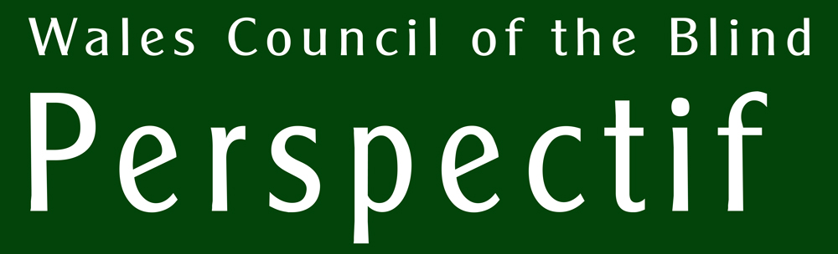
People who lose their sight are often unaware of the support that is available to them to help restore confidence, independence or simply to enable them to maintain their lifestyle. Clubs, sports and leisure opportunities, social care, technical jargon, books and leaflets are all highlighted in the portal, offering crucial help at a critical time.

Perspectif website: www.wcb-ccd.org.uk/perspectif/

Mae’r ddogfen hon ar gael yn Gymraeg. Dylech ofyn am gopi ar y ddesg gofrestru.



